**VISVESVARAYA TECHNOLOGICAL UNIVERSITY**

**“JnanaSangama”, Belgaum -590014, Karnataka.**



**LAB REPORT**

**on**

**Object Oriented Java Programming (23CS3PCOOJ)**

***Submitted by***

**Danish K (1BM23CS086)**

***in partial fulfillment for the award of the degree of***

**BACHELOR OF ENGINEERING**

***in***

**COMPUTER SCIENCE AND ENGINEERING**



**B.M.S. COLLEGE OF ENGINEERING**

**(Autonomous Institution under VTU)**

**BENGALURU-560019**

**Sep-2024 to Jan-2025**

**B.M.S. College of Engineering,**

**Bull Temple Road, Bangalore 560019**

(Affiliated To Visvesvaraya Technological University, Belgaum)

**Department of Computer Science and Engineering**



**CERTIFICATE**

This is to certify that the Lab work entitled “Object Oriented Java Programming (23CS3PCOOJ)” carried out by **Danish Kodavanti (1BM23CS086),** who is bonafide student of **B.M.S. College of Engineering.** It is in partial fulfillment for the award of **Bachelor of Engineering in Computer Science and Engineering** of the Visvesvaraya Technological University, Belgaum. The Lab report has been approved as it satisfies the academic requirements in respect of an Object Oriented Java Programming (23CS3PCOOJ) work prescribed for the said degree.

|  |  |
| --- | --- |
| Lab faculty Incharge Name  Assistant Professor  Department of CSE, BMSCE | Dr. Jyothi S Nayak  Professor & HOD  Department of CSE, BMSCE |

**Index**

|  |  |  |  |
| --- | --- | --- | --- |
| **Sl.**  **No.** | **Date** | **Experiment Title** | **Page No.** |
| 1 | 1/10/2024 | Lab Program - 1 | 4-7 |
| 2 | 8/10/2024 | Lab Program - 2 | 8-16 |
| 3 | 15/10/2024 | Lab Program - 3 | 17-24 |
| 4 | 22/10/2024 | Lab Program - 4 | 25-33 |
| 5 | 29/10/2024 | Lab Program - 5 | 34-46 |
| 6 | 12/11/2024 | Lab Program – 6 | 47-56 |
| 7 | 19/11/2024 | Lab Program – 7 | 57-64 |
| 8 | 26/11/2024 | Lab Program – 8 | 65-70 |
| 9 | 3/12/2024 | Lab Program – 9 | 71-74 |
| 10 | 3/12/2024 | Lab Program – 10 | 75 |

Github-link(<https://github.com/Danishkodavanti/java_lab_sem3>)

Program 1

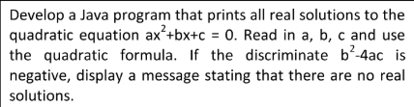

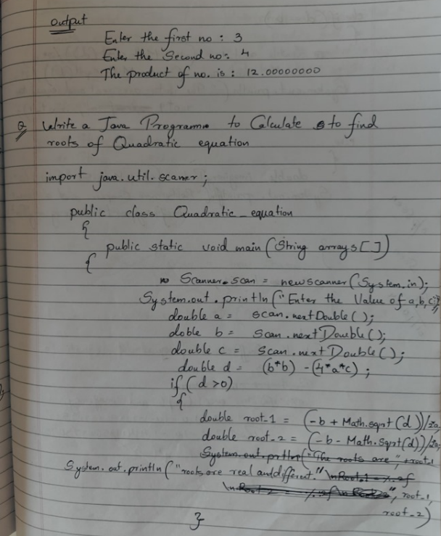

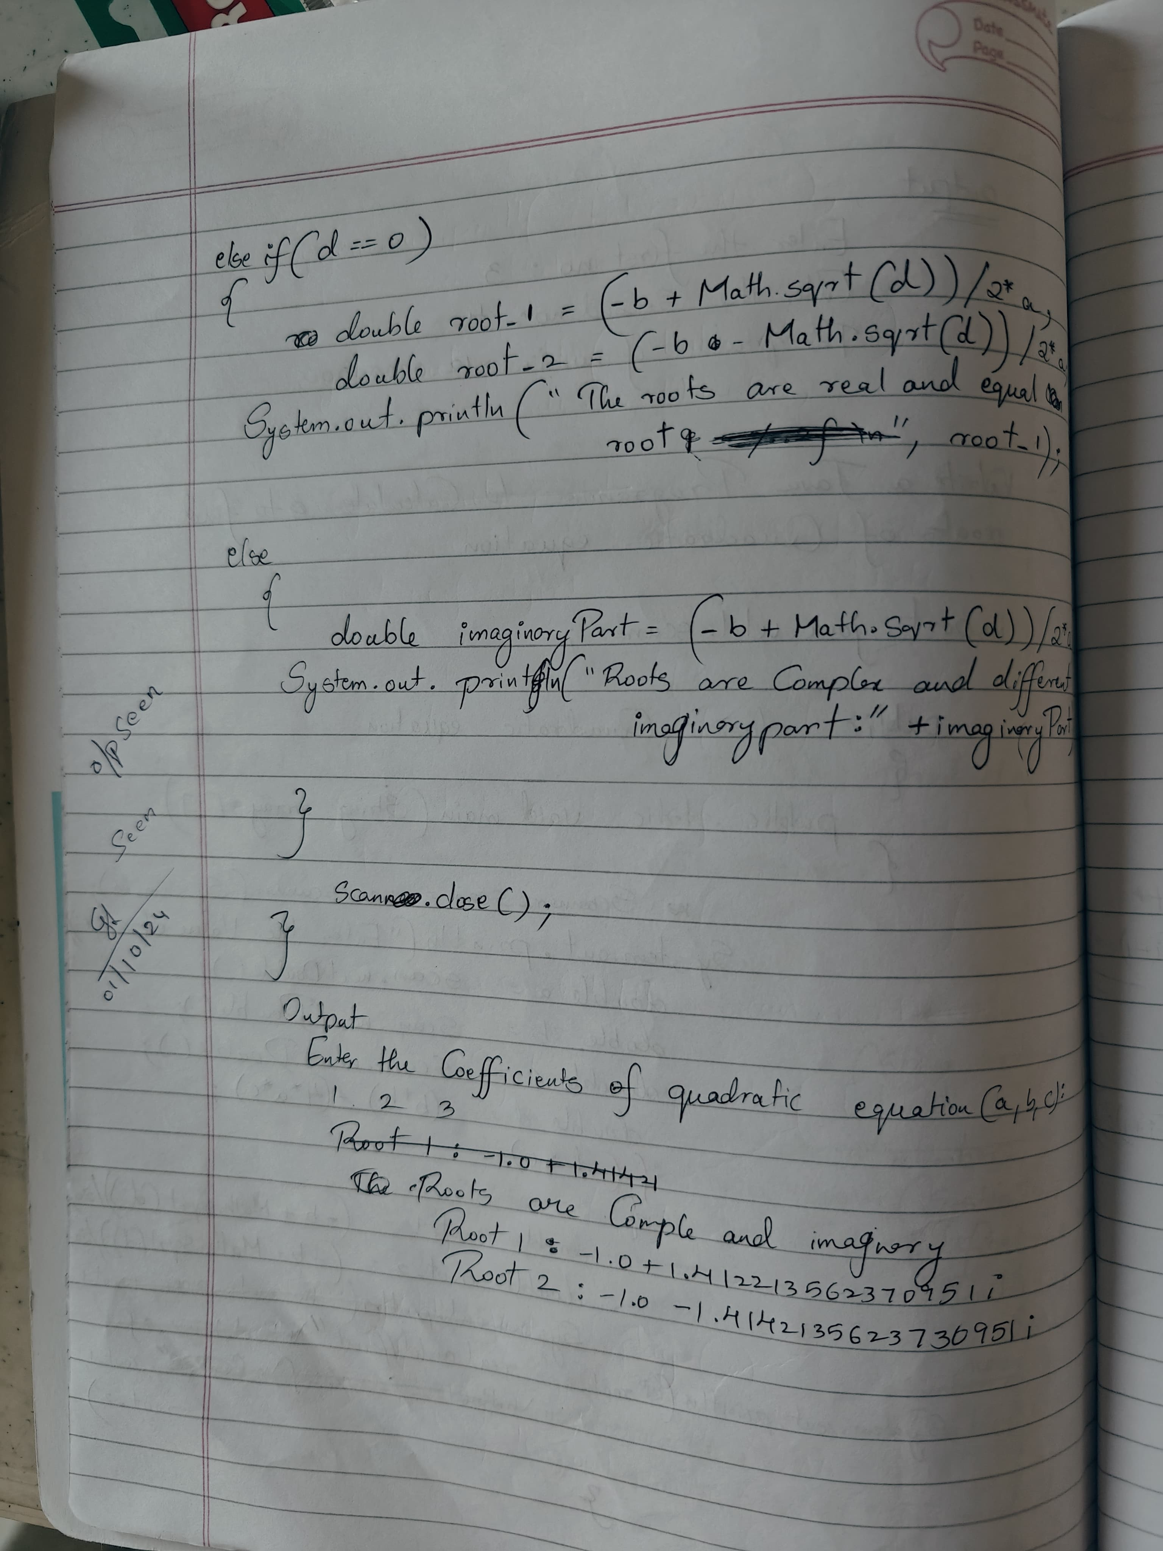

CODE:

import java.util.Scanner;

public class QuadraticEquation {

    public static void main(String[] args) {

        // Scanner object for taking user input

        Scanner scanner = new Scanner(System.in);

        // Input values for a, b, and c

        System.out.print("Enter the value of a: ");

        double a = scanner.nextDouble();

        System.out.print("Enter the value of b: ");

        double b = scanner.nextDouble();

        System.out.print("Enter the value of c: ");

        double c = scanner.nextDouble();

        // Calculate the discriminant

        double discriminant = b * b - 4 * a * c;

        // Check if discriminant is positive, negative, or zero

        if (discriminant > 0) {

            // Two real and distinct roots

            double root1 = (-b + Math.sqrt(discriminant)) / (2 * a);

            double root2 = (-b - Math.sqrt(discriminant)) / (2 * a);

            System.out.println("The roots are real and distinct.");

            System.out.println("Root 1: " + root1);

            System.out.println("Root 2: " + root2);

        } else if (discriminant == 0) {

            // One real root (both roots are the same)

            double root = -b / (2 * a);

            System.out.println("The roots are real and the same.");

            System.out.println("Root: " + root);

        } else {

            // Complex roots

            double realPart = -b / (2 * a);

            double imaginaryPart = Math.sqrt(-discriminant) / (2 * a);

            System.out.println("The roots are complex and distinct.");

            System.out.println("Root 1: " + realPart + " + " + imaginaryPart + "i");

            System.out.println("Root 2: " + realPart + " - " + imaginaryPart + "i");

        }

        System.out.println("Name: Danish k \n USN: 1BM23CS086");

        scanner.close();

    }

}

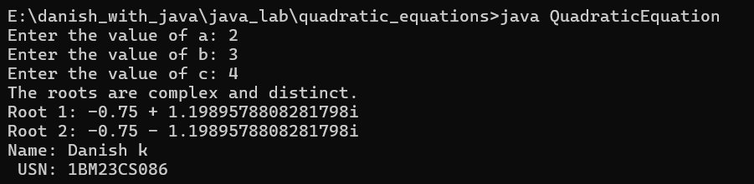

**PROGRAM 2**

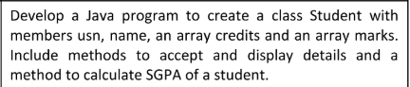

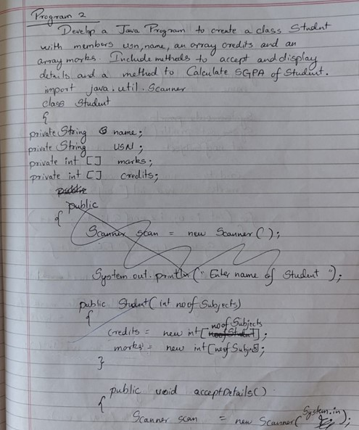

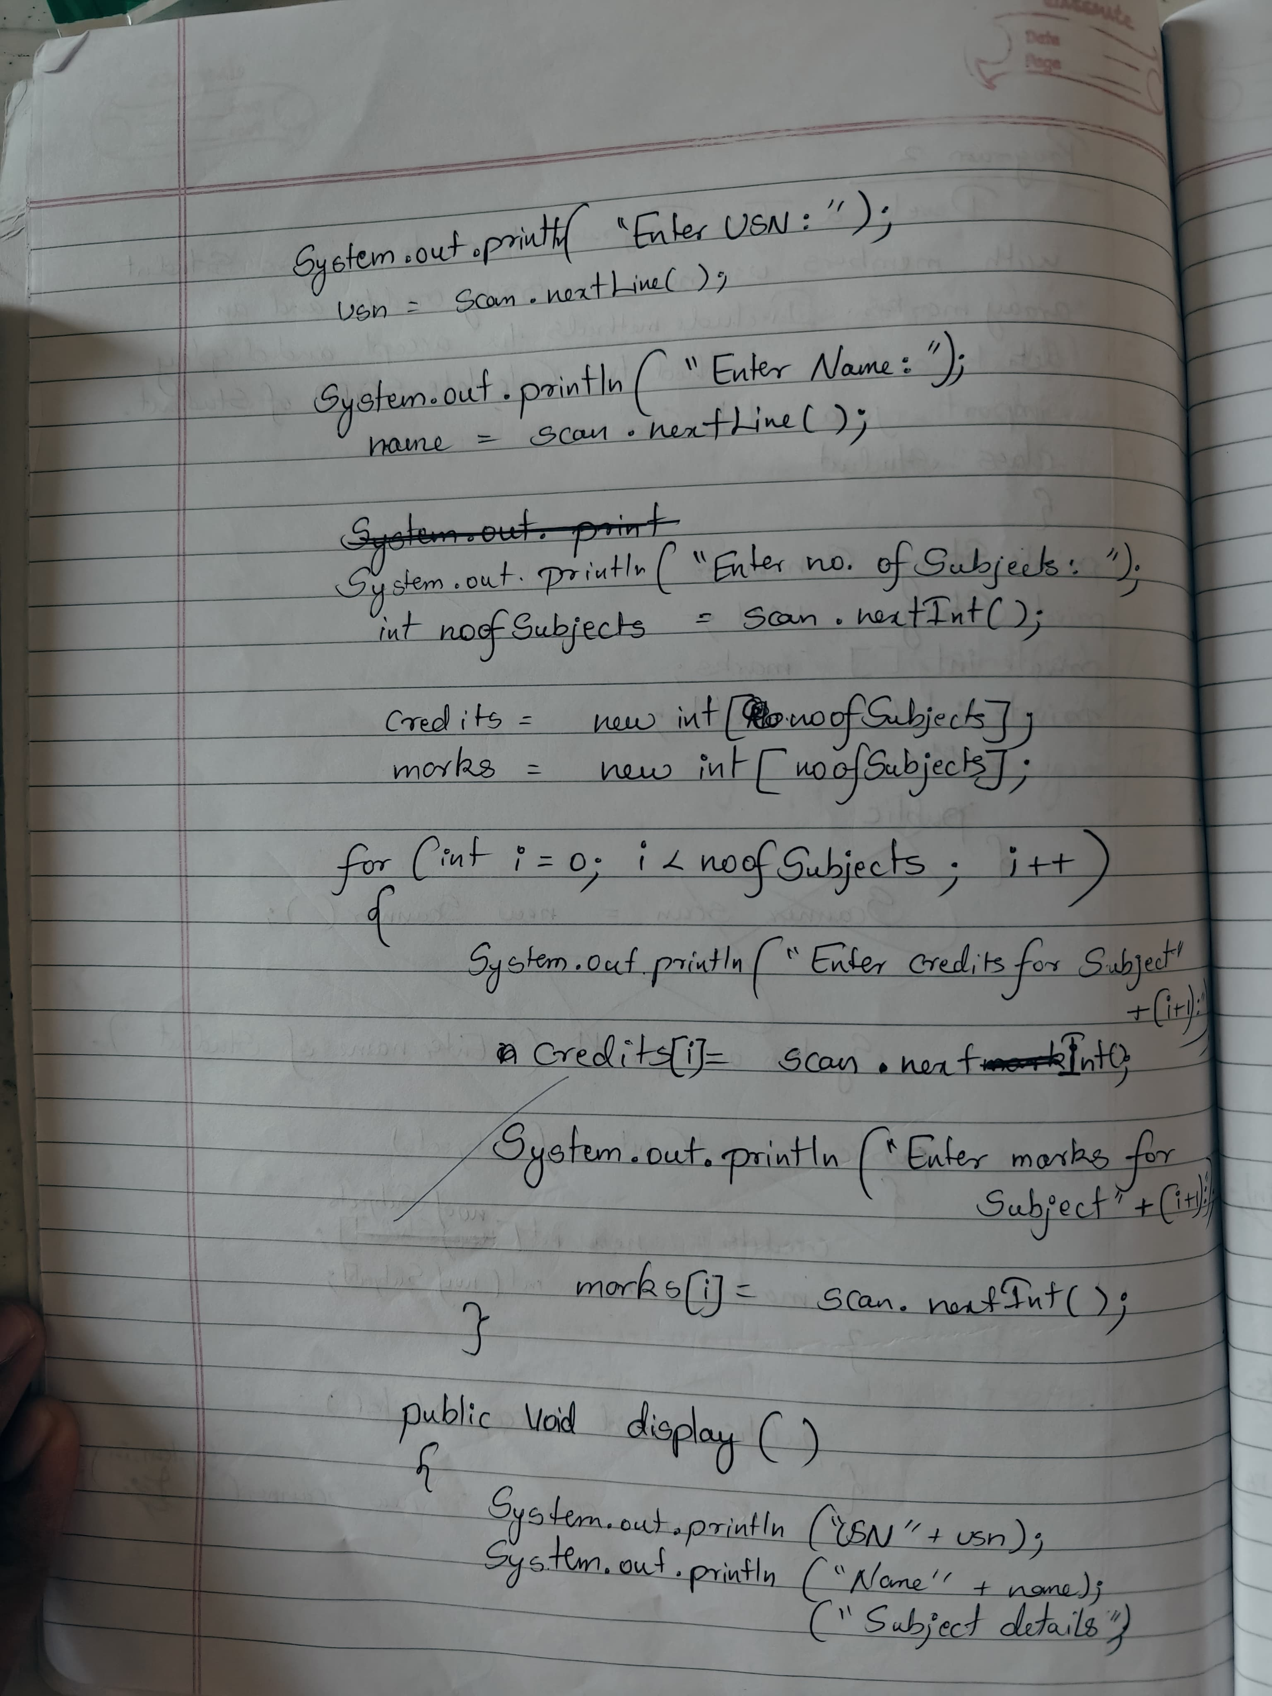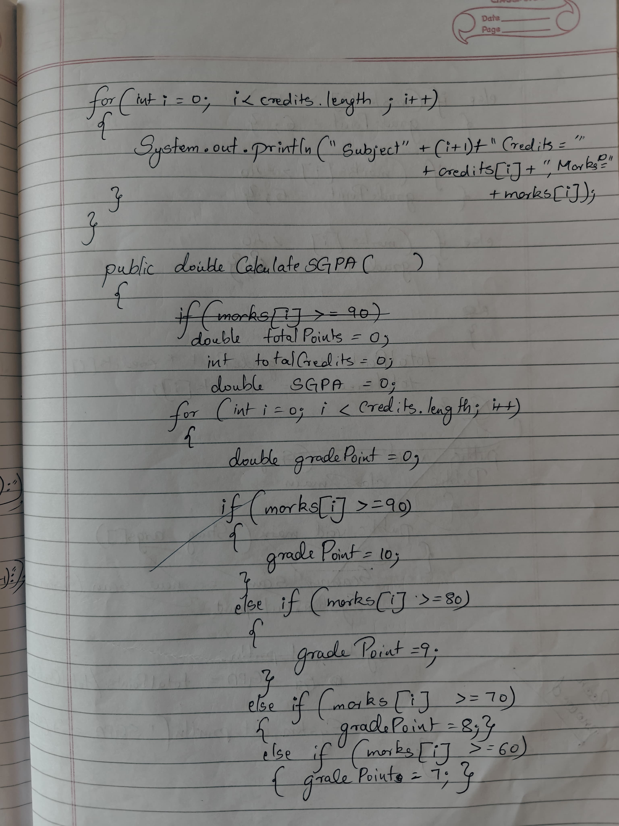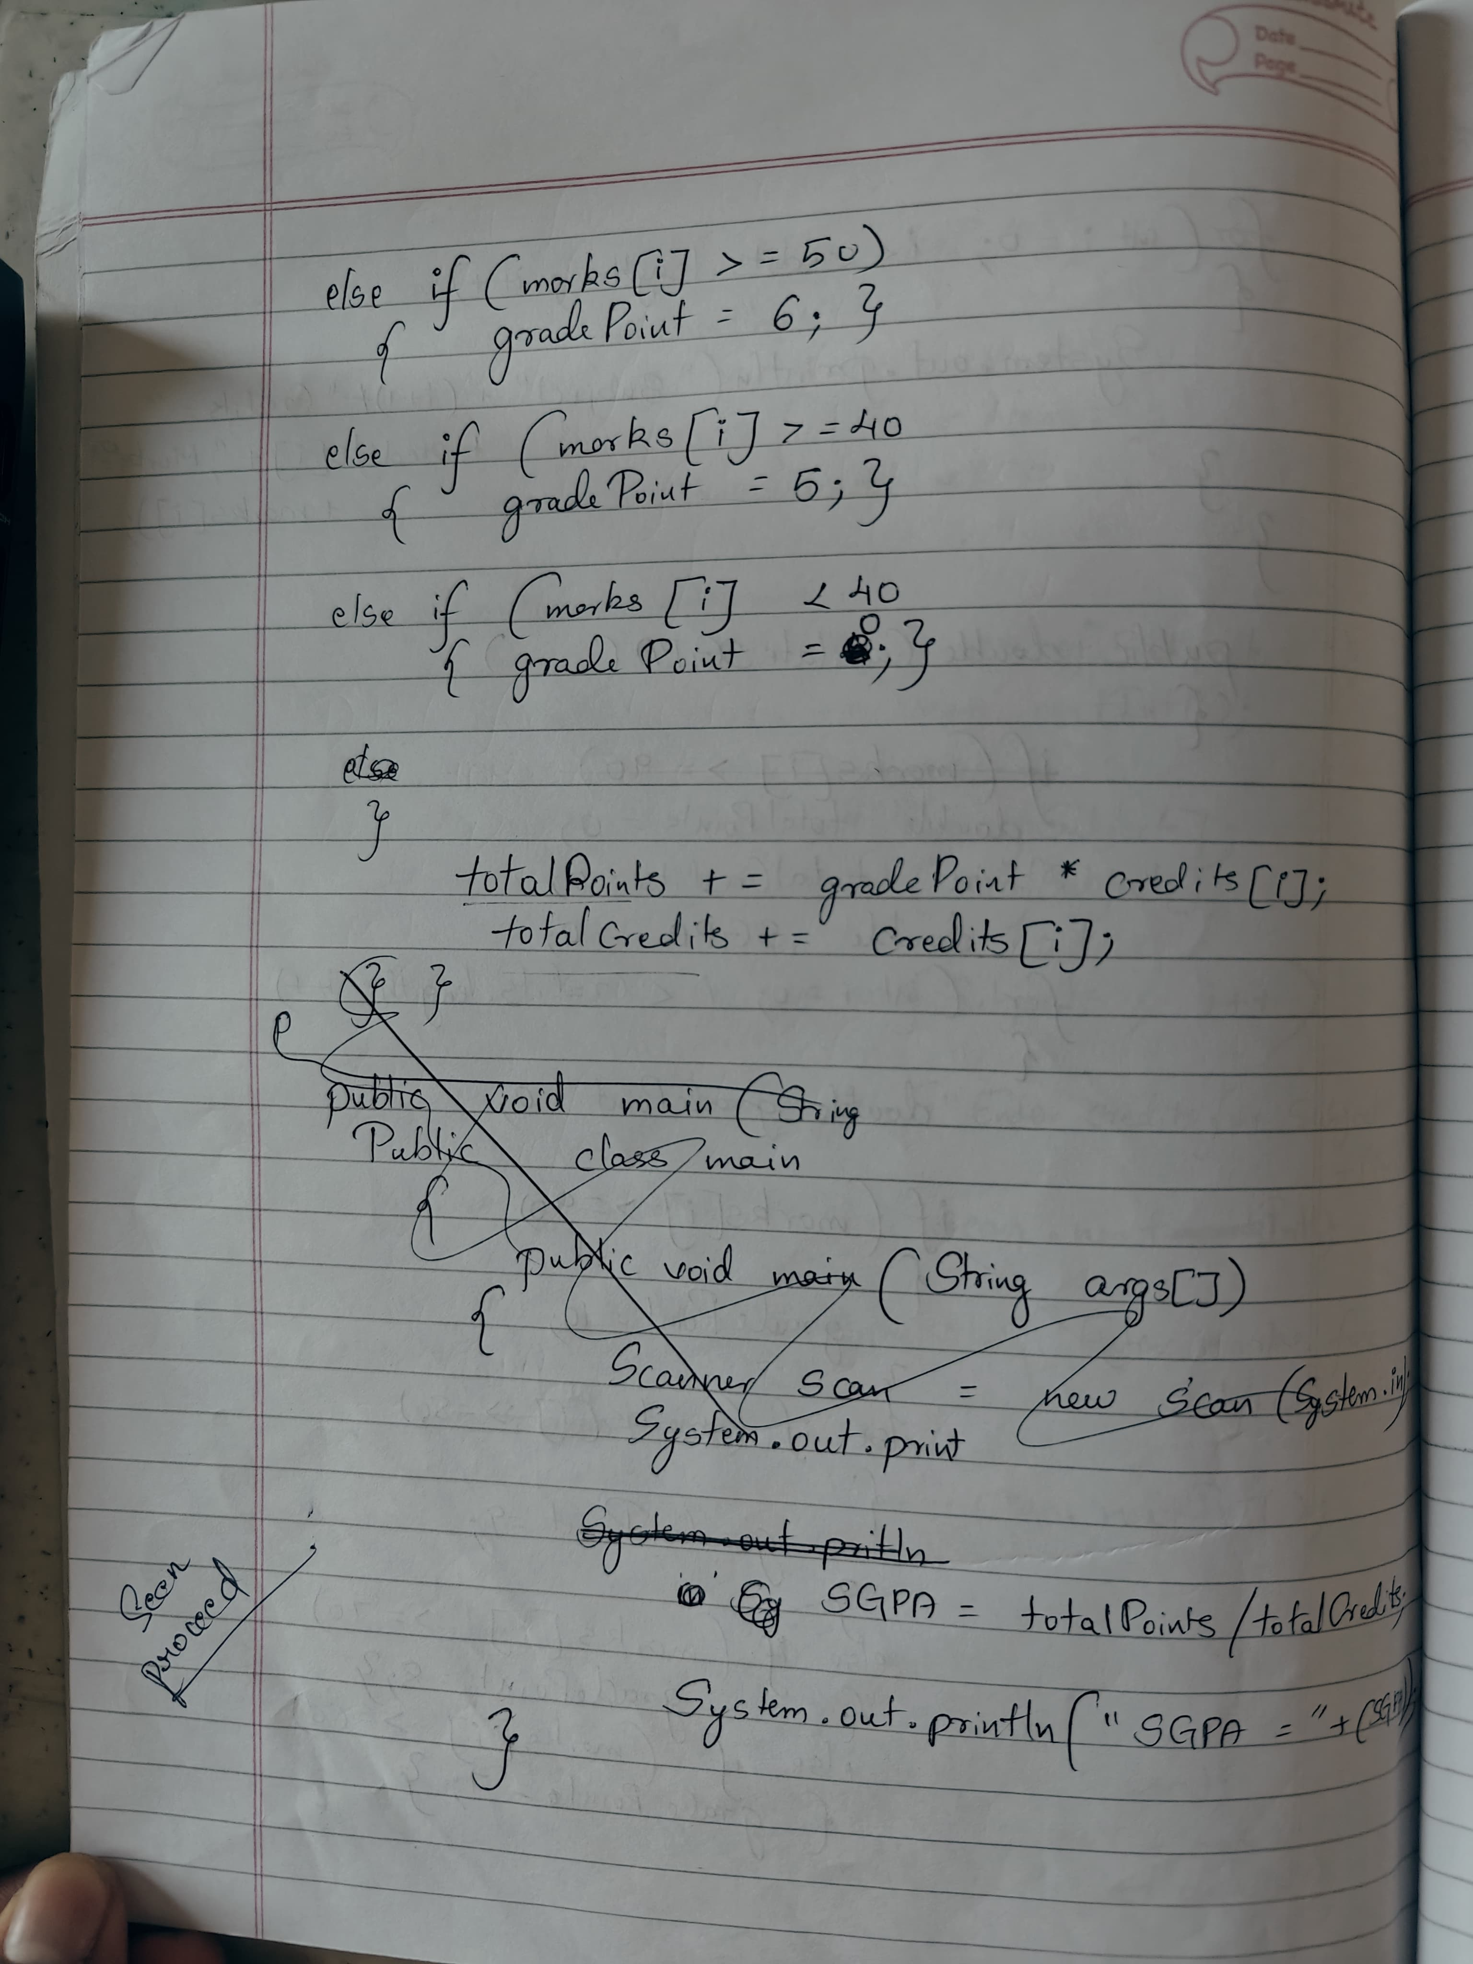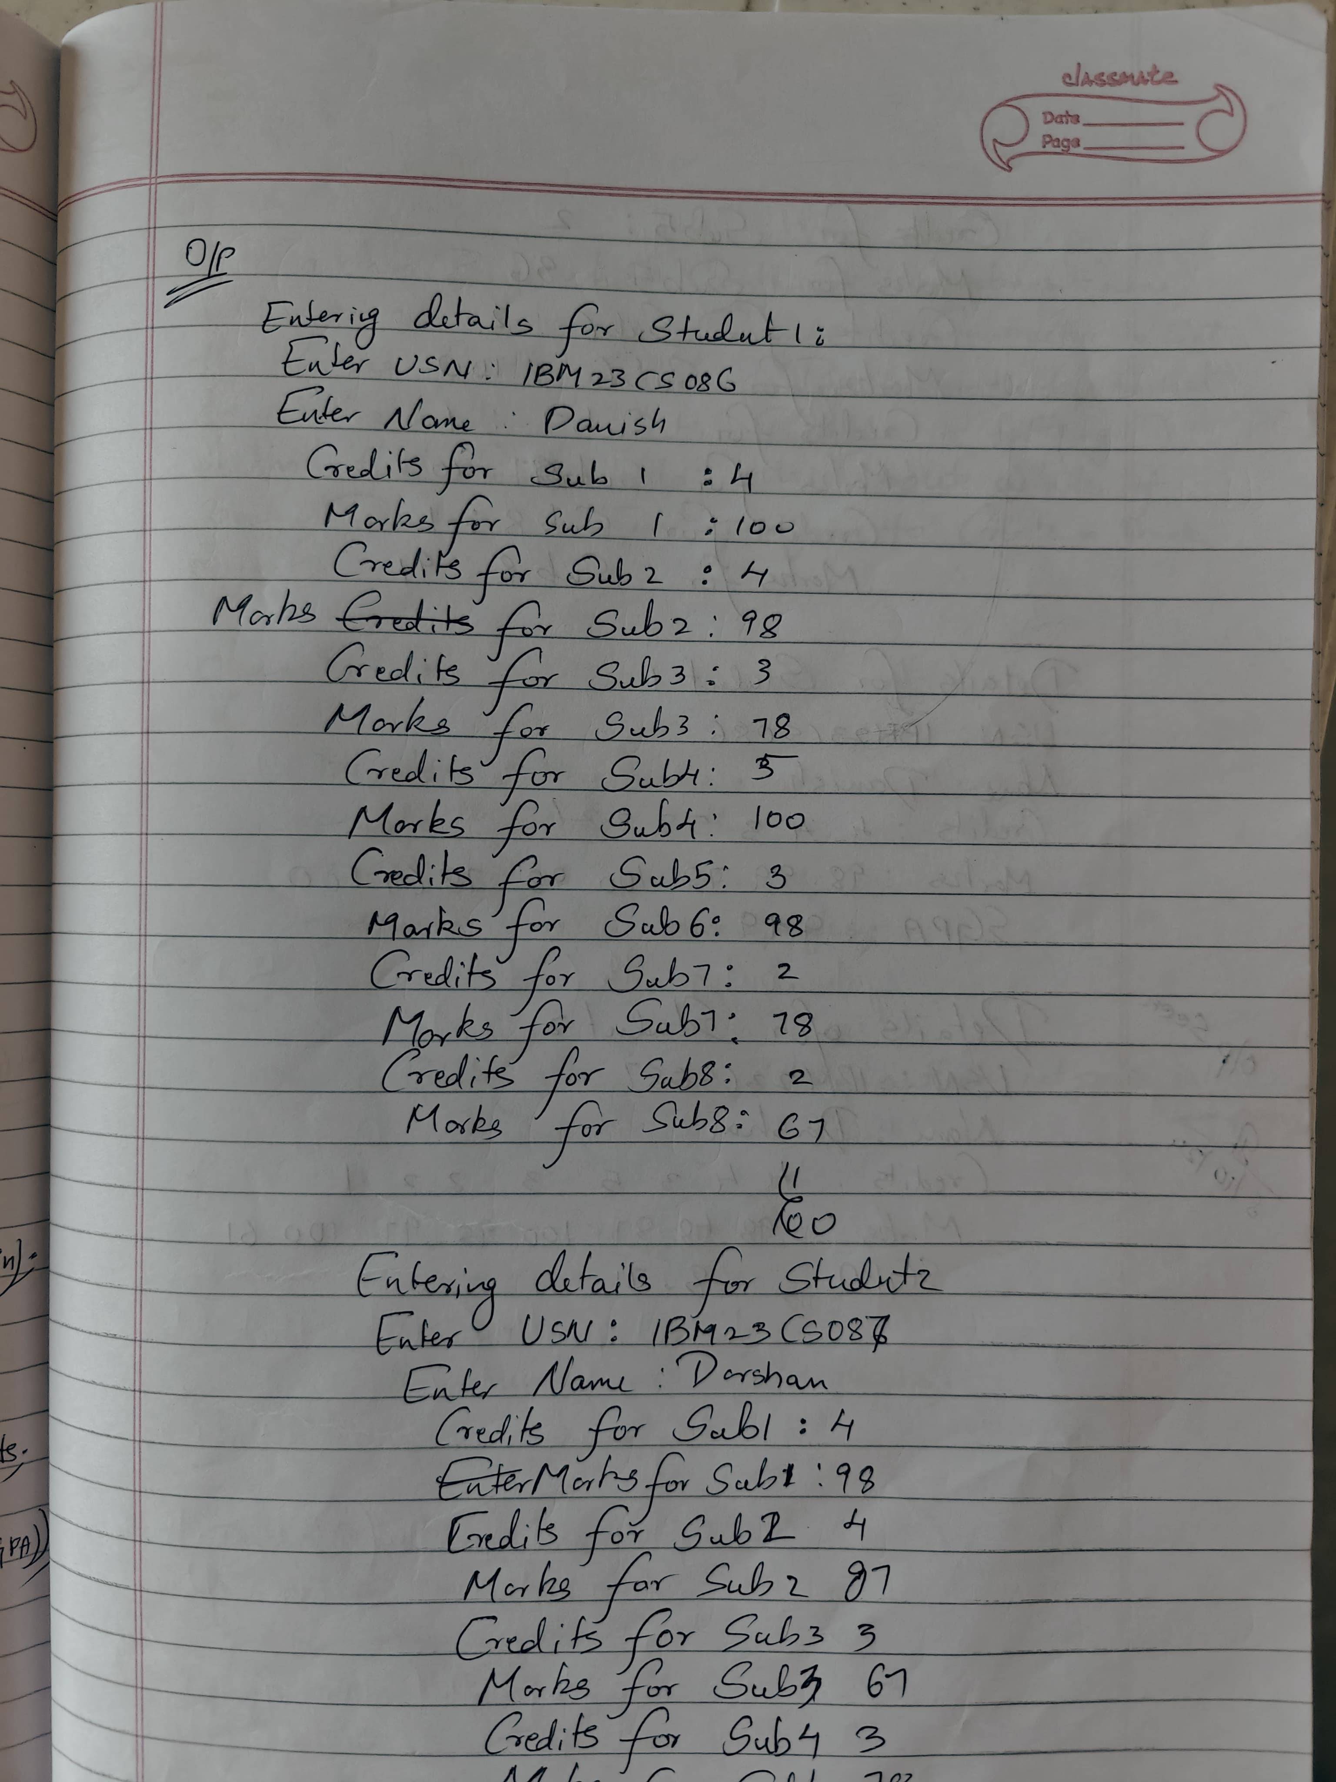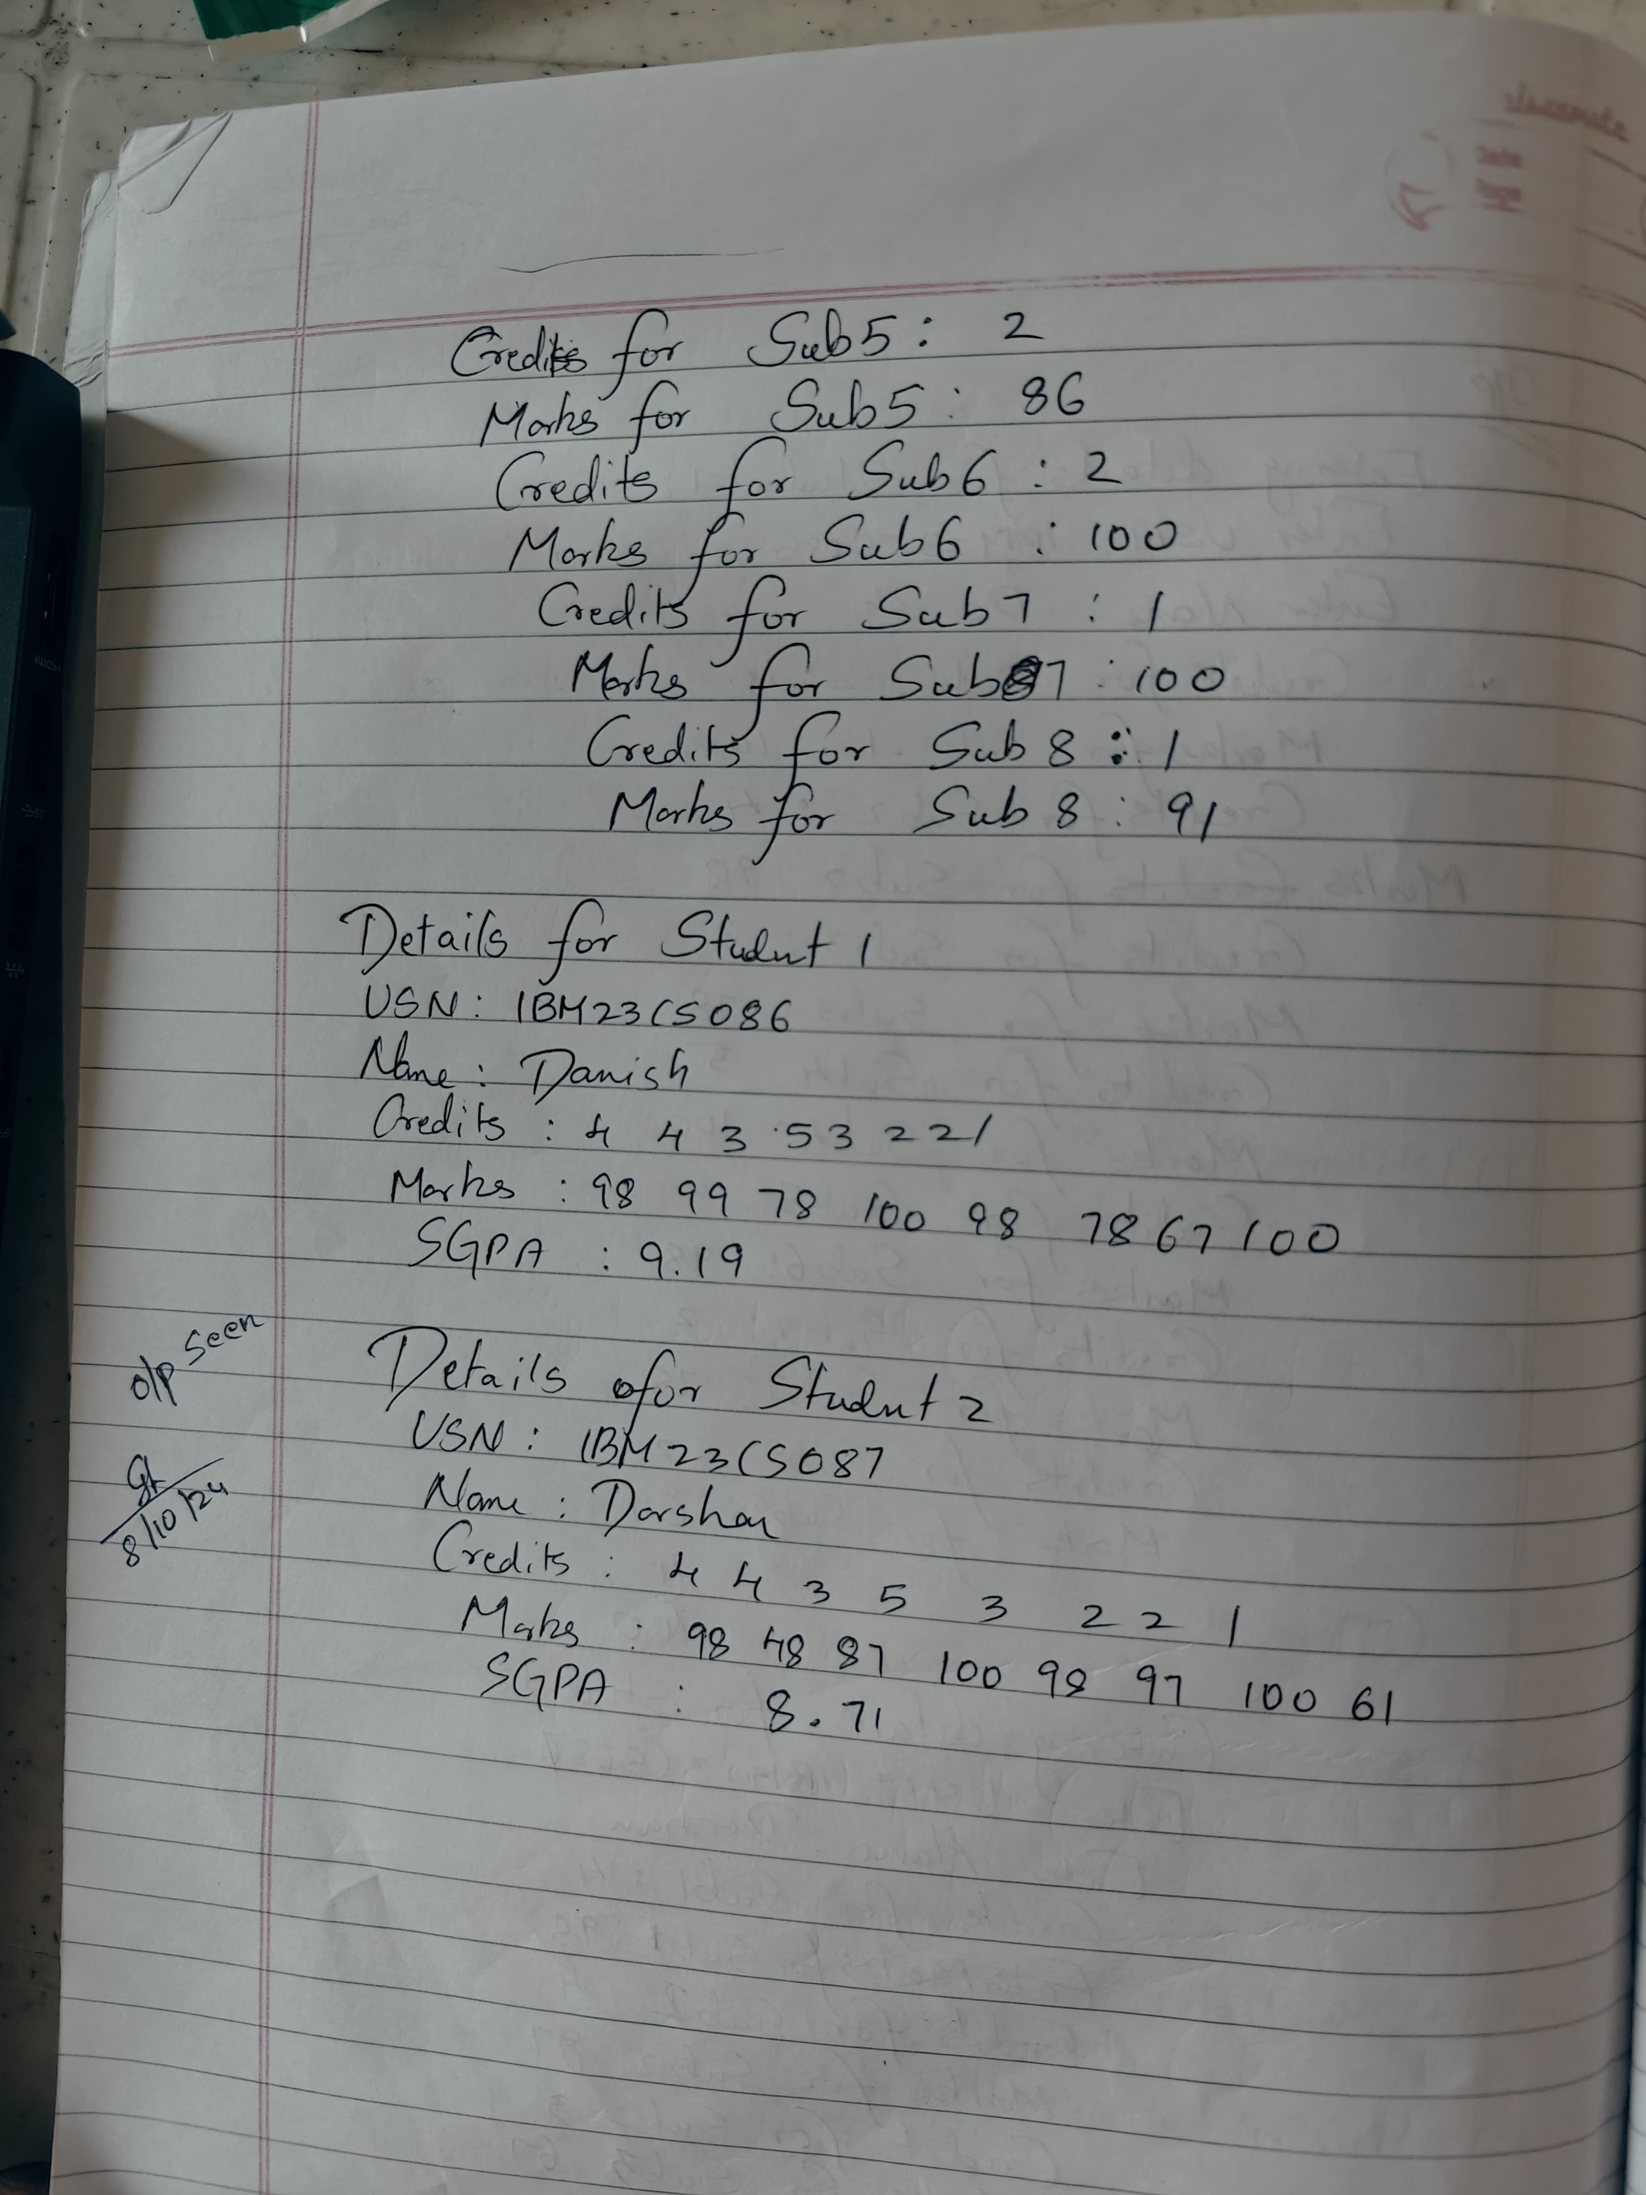

CODE:

import java.util.Scanner;

class Student {

    private String usn;

    private String name;

    private int[] credits;

    private int[] marks;

    private int numSubjects;

    // Method to accept student details

    public void acceptDetails() {

        Scanner scanner = new Scanner(System.in);

        System.out.print("Enter USN: ");

        usn = scanner.nextLine();

        System.out.print("Enter Name: ");

        name = scanner.nextLine();

        System.out.print("Enter number of subjects: ");

        numSubjects = scanner.nextInt();

        credits = new int[numSubjects];

        marks = new int[numSubjects];

        System.out.println("Enter credits for each subject:");

        for (int i = 0; i < numSubjects; i++) {

            System.out.print("Credits for Subject " + (i + 1) + ": ");

            credits[i] = scanner.nextInt();

        }

        System.out.println("Enter marks for each subject:");

        for (int i = 0; i < numSubjects; i++) {

            System.out.print("Marks for Subject " + (i + 1) + ": ");

            marks[i] = scanner.nextInt();

        }

    }

    // Method to calculate SGPA

    public double calculateSGPA() {

        int totalCredits = 0;

        int weightedGradePoints = 0;

        for (int i = 0; i < numSubjects; i++) {

            int gradePoint = calculateGradePoint(marks[i]);

            weightedGradePoints += gradePoint * credits[i];

            totalCredits += credits[i];

        }

        return (double) weightedGradePoints / totalCredits;

    }

    // Method to calculate grade point based on marks

    private int calculateGradePoint(int marks) {

        if (marks >= 90) return 10;

        else if (marks >= 80) return 9;

        else if (marks >= 70) return 8;

        else if (marks >= 60) return 7;

        else if (marks >= 50) return 6;

        else if (marks >= 40) return 5;

        else return 0; // Fail

    }

    // Method to display student details

    public void displayDetails() {

        System.out.println("USN: " + usn);

        System.out.println("Name: " + name);

        System.out.println("SGPA: " + calculateSGPA());

    }

}

public class Main {

    public static void main(String[] args) {

        Student student = new Student();

        student.acceptDetails();

        student.displayDetails();

    }

}

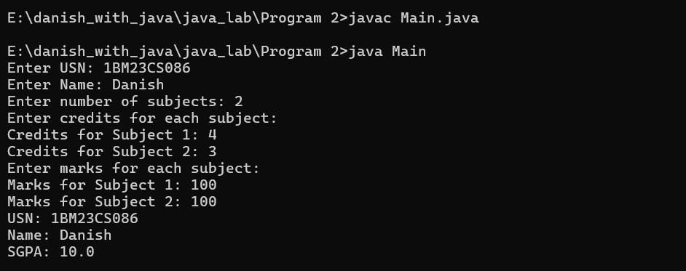

**PROGRAM 3**

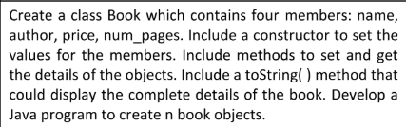

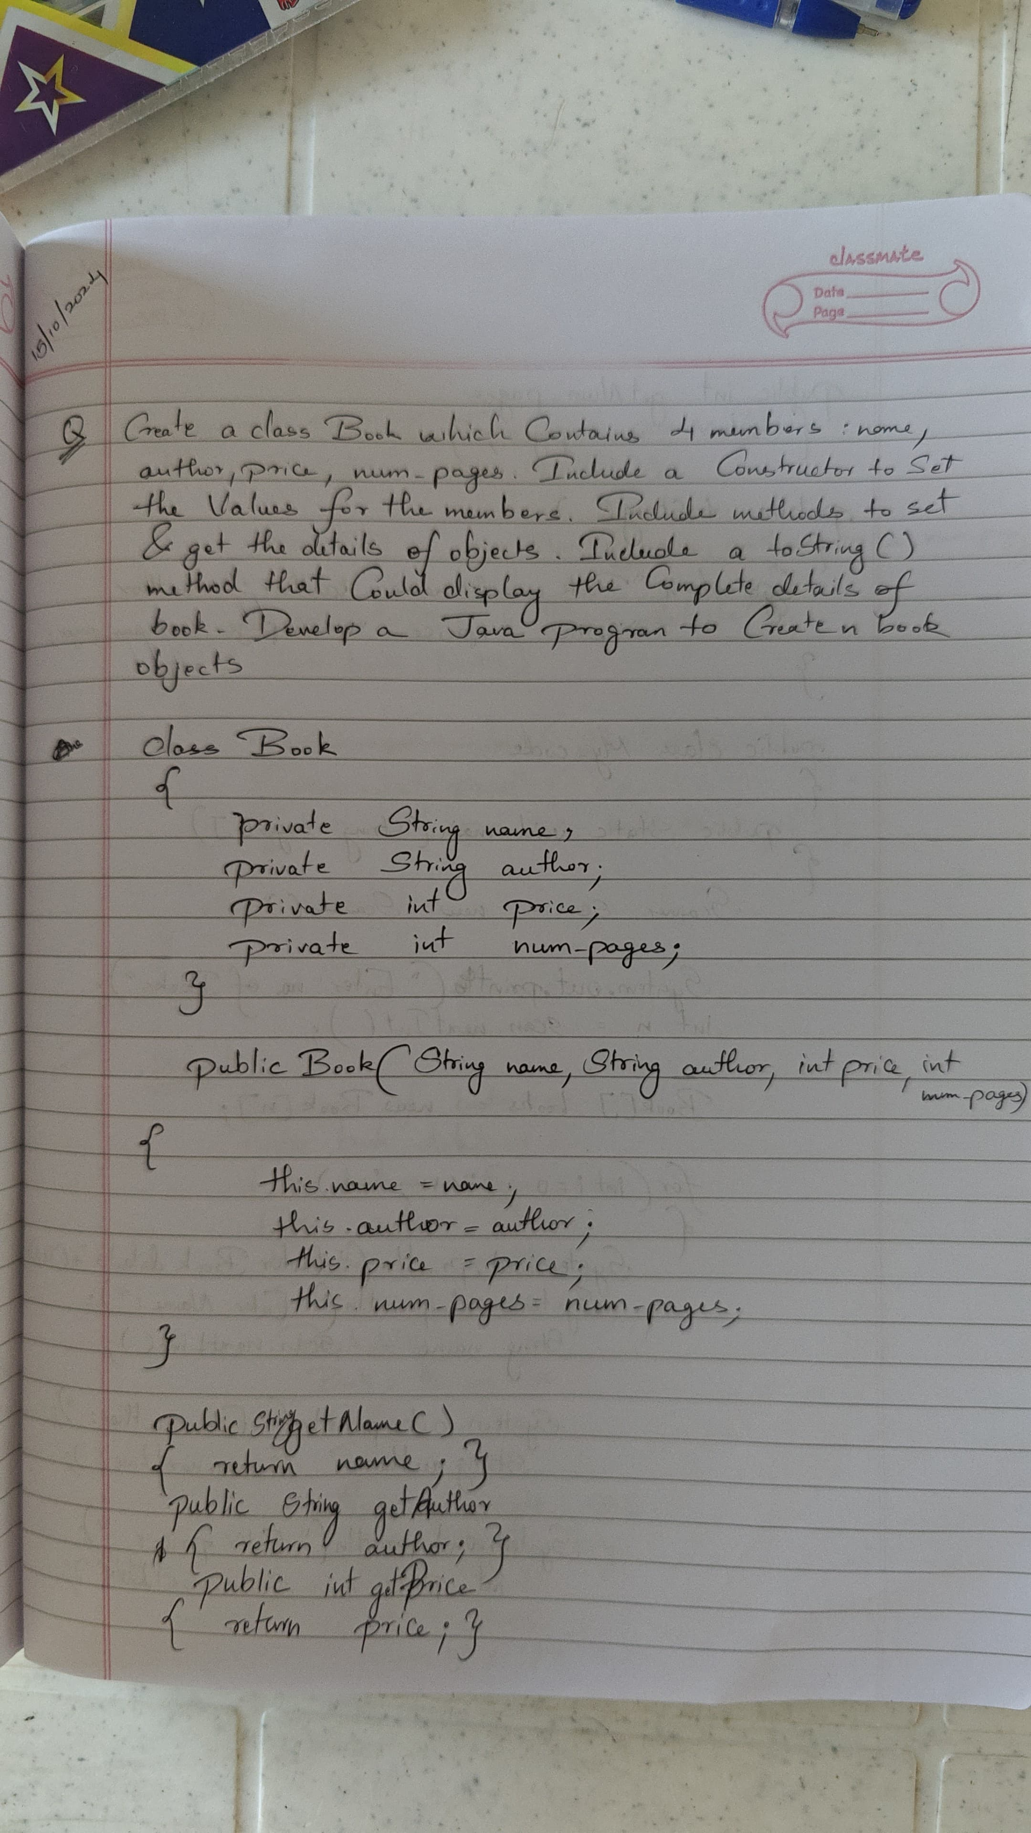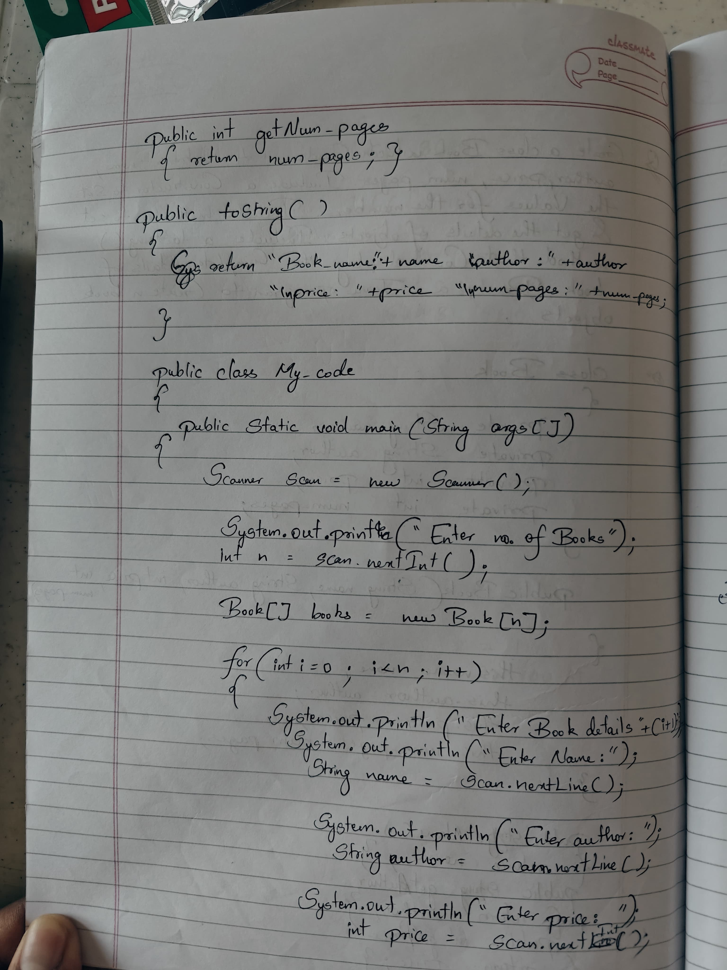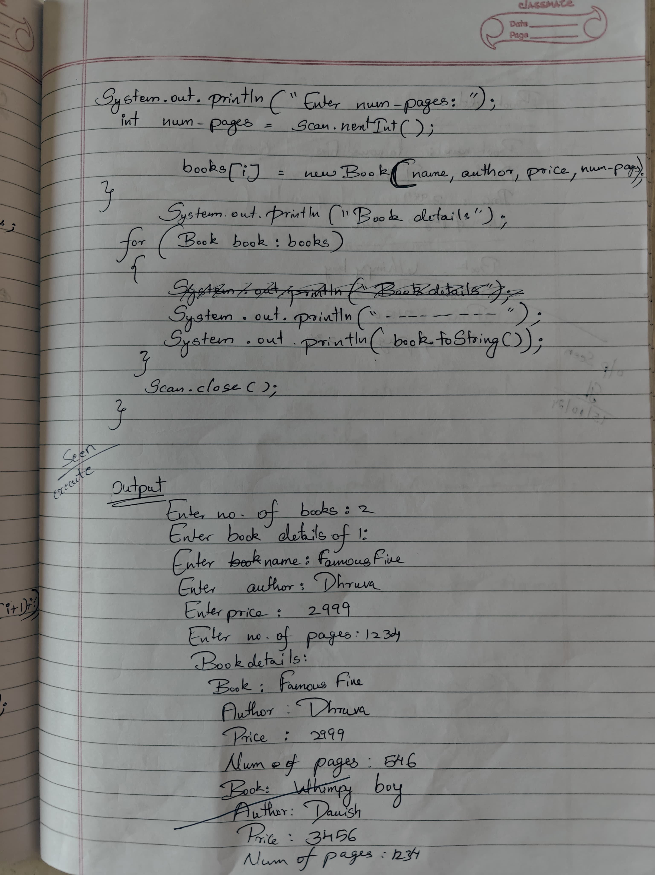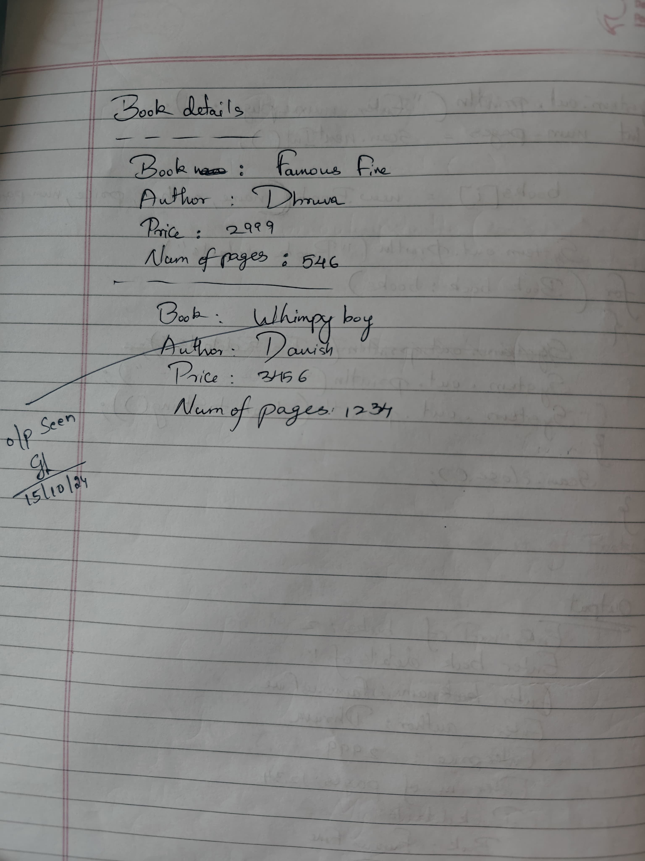

CODE:

import java.util.Scanner;

// Class to represent a Book

class Book {

    // Member variables

    private String name;

    private String author;

    private int price;

    private int num_pages;

    // Constructor to initialize the book details

    public Book(String name, String author, int price, int num_pages) {

        this.name = name;

        this.author = author;

        this.price = price;

        this.num_pages = num_pages;

    }

    // Getter

    public String getName() {

        return name;

    }

    public String getAuthor() {

        return author;

    }

    public int getPrice() {

        return price;

    }

    public int getNumPages() {

        return num_pages;

    }

    // toString method to display book details

    //@Override

    public String toString() {

        return "Book Name: " + name + "\nAuthor: " + author + "\nPrice: " + price + "\nNumber of Pages: " + num_pages;

    }

}

public class App {

    public static void main(String[] args) {

        // Scanner object for user input

        Scanner scan = new Scanner(System.in);

        // Asking the user for the number of books

        System.out.print("Enter the number of books: ");

        int n = scan.nextInt();

        scan.nextLine();  // consume newline

        // Array to store Book objects

        Book[] books = new Book[n];

        // Loop to accept details of each book

        for (int i = 0; i < n; i++) {

            System.out.println("Enter details of book " + (i + 1) + ":");

            System.out.print("Enter name: ");

            String name = scan.nextLine();

            System.out.print("Enter author: ");

            String author = scan.nextLine();

            System.out.print("Enter price: ");

            int price = scan.nextInt();

            System.out.print("Enter number of pages: ");

            int num_pages = scan.nextInt();

            scan.nextLine();  // consume newline

            // Creating a new Book object and storing it in the array

            books[i] = new Book(name, author, price, num_pages);

        }

        // Displaying all the books

        System.out.println("\nBook Details:");

        for (Book book : books) {

            System.out.println(book.toString());

            System.out.println("--------------------");

        }

        // Closing the scanner to prevent resource leak

        scan.close();

        System.out.println("Name: Danish\n USN:1BM23CS086");

    }

}

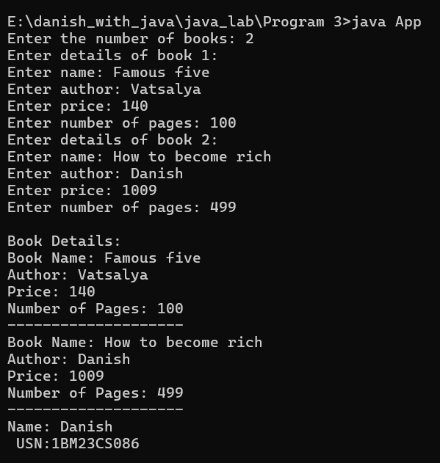

**PROGRAM 4**

Create an abstract class Animal with two methods, eat and sleep. Create three subclasses Lion, Deer, and Tiger that extend the Animal class and implement the eat and sleep methods based on their specific behavior.

Write a Main class to create objects of these subclasses and demonstrate their behavior by calling the eat and sleep methods. Include your name and USN in the output**.**

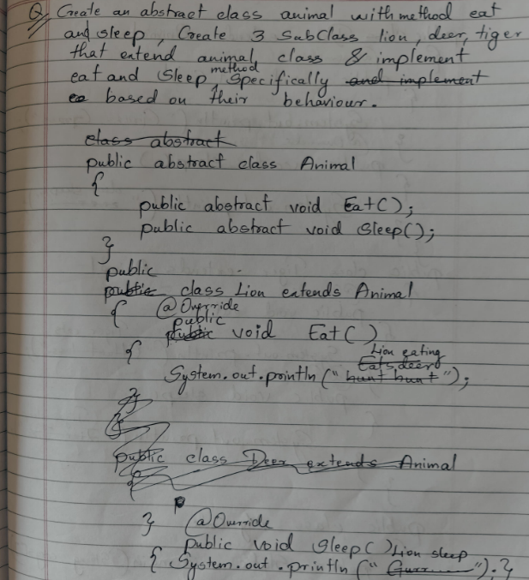

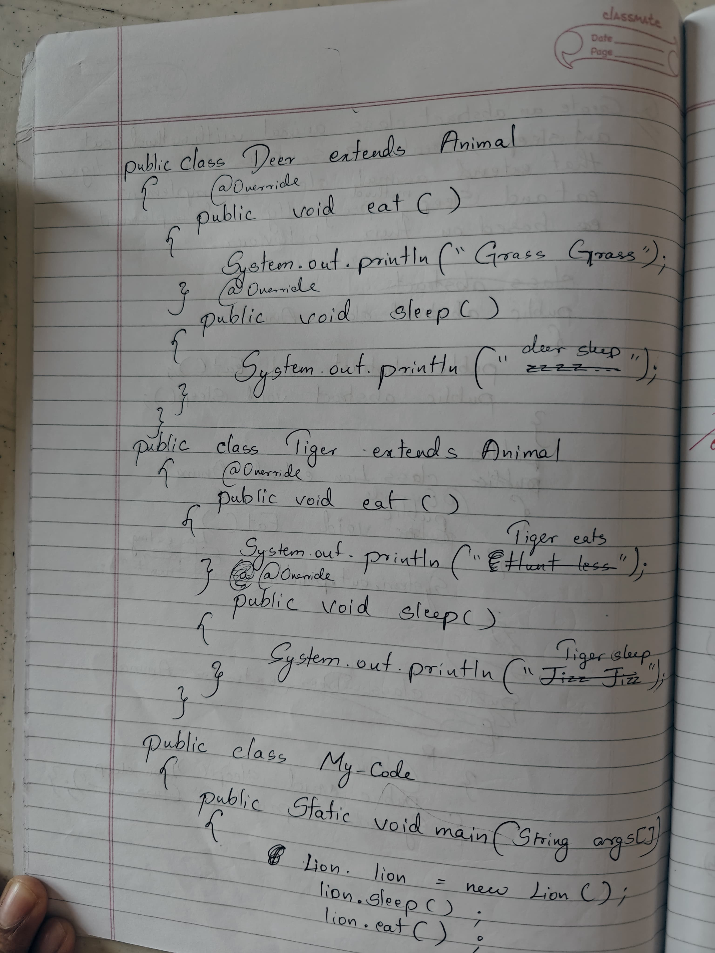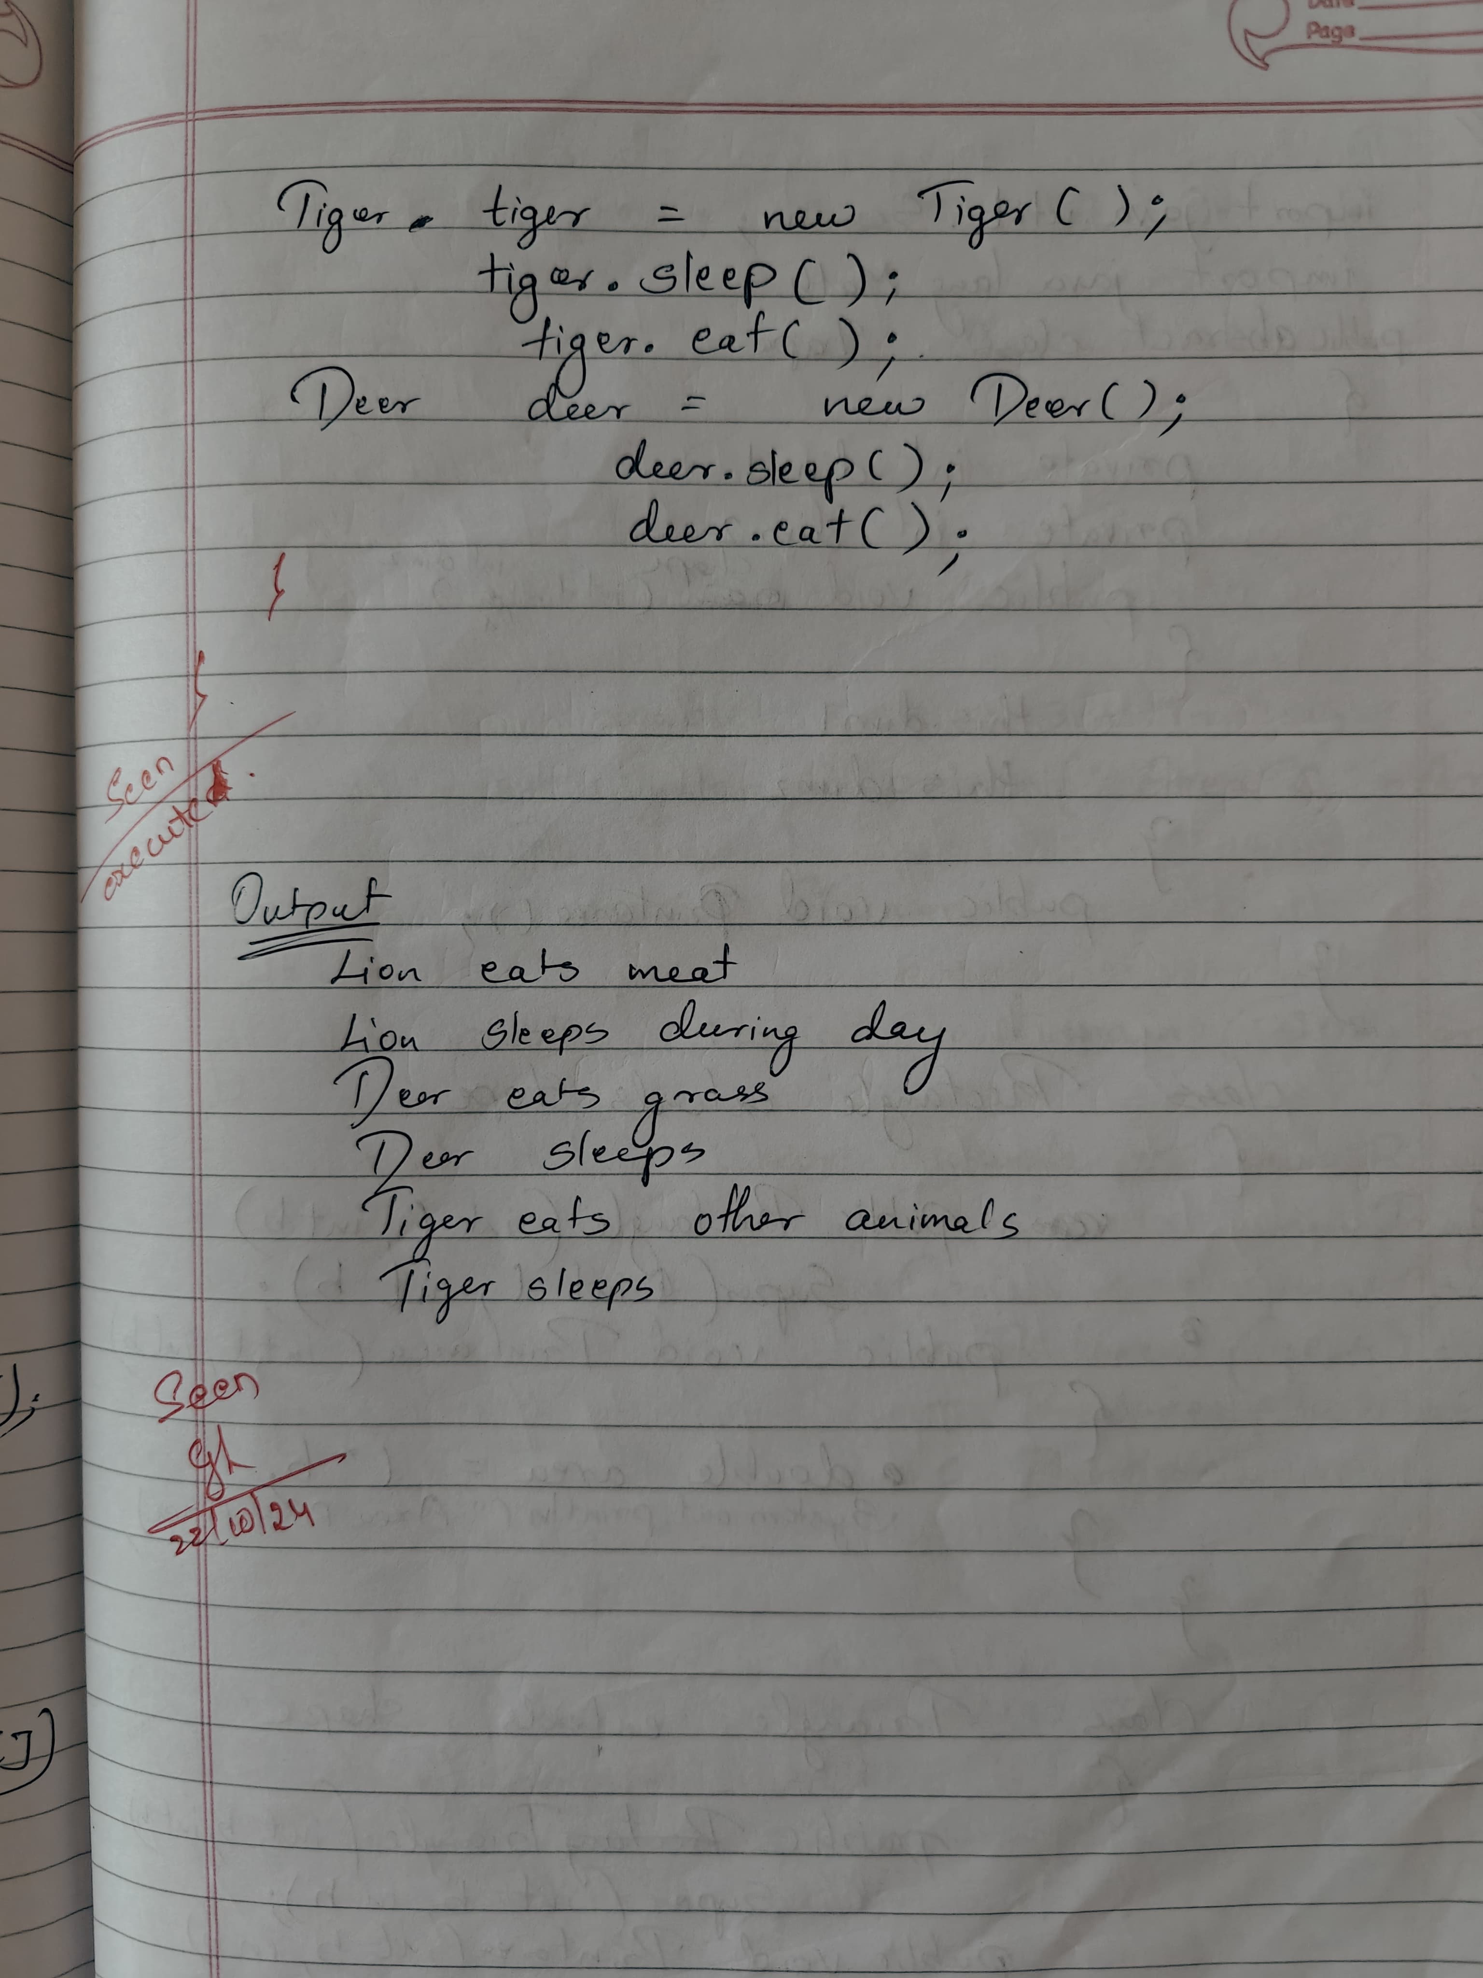

CODE:

abstract class Animal {

    // Abstract method eat

    abstract void eat();

    // Abstract method sleep

    abstract void sleep();

}

// Lion class extending Animal

class Lion extends Animal {

    @Override

    void eat() {

        System.out.println("The Lion hunts and eats meat.");

    }

    @Override

    void sleep() {

        System.out.println("The Lion sleeps for 16-20 hours a day.");

    }

}

// Deer class extending Animal

class Deer extends Animal {

    @Override

    void eat() {

        System.out.println("The Deer grazes on grass, leaves, and shrubs.");

    }

    @Override

    void sleep() {

        System.out.println("The Deer sleeps during the night and is alert during the day.");

    }

}

// Tiger class extending Animal

class Tiger extends Animal {

    @Override

    void eat() {

        System.out.println("The Tiger hunts and eats large prey like deer or wild boar.");

    }

    @Override

    void sleep() {

        System.out.println("The Tiger sleeps in the shade during the day and hunts at night.");

    }

}

// Main class to test the behavior

public class Main {

    public static void main(String[] args) {

        // Creating objects of Lion, Deer, and Tiger

        Animal lion = new Lion();

        Animal deer = new Deer();

        Animal tiger = new Tiger();

        // Testing the behavior of each animal

        lion.eat();

        lion.sleep();

        deer.eat();

        deer.sleep();

        tiger.eat();

        tiger.sleep();

        System.out.println("NAME:Danish \nUSN:1BM23CS086");

    }

}

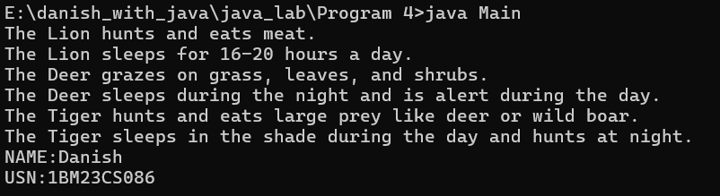

**PROGRAM 4(2):**

Develop a Java program to create an abstract class named Shape that contains two integers and an empty method named printArea) Provide three classes named Rectangle, Triangle and Circle such that each one of the classes extends the class Shape. Each one of the classes contain only the method printArea) that prints the area of the given shape.

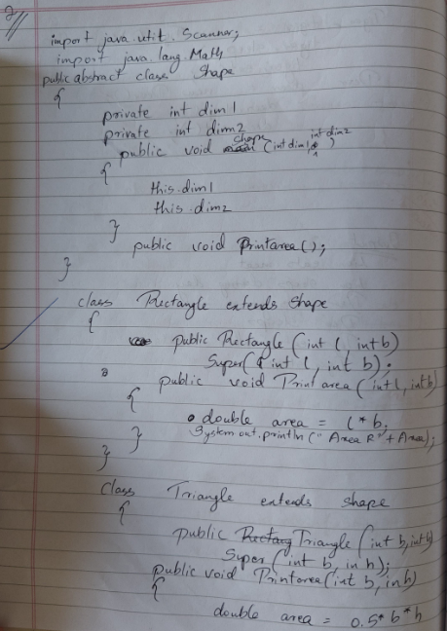

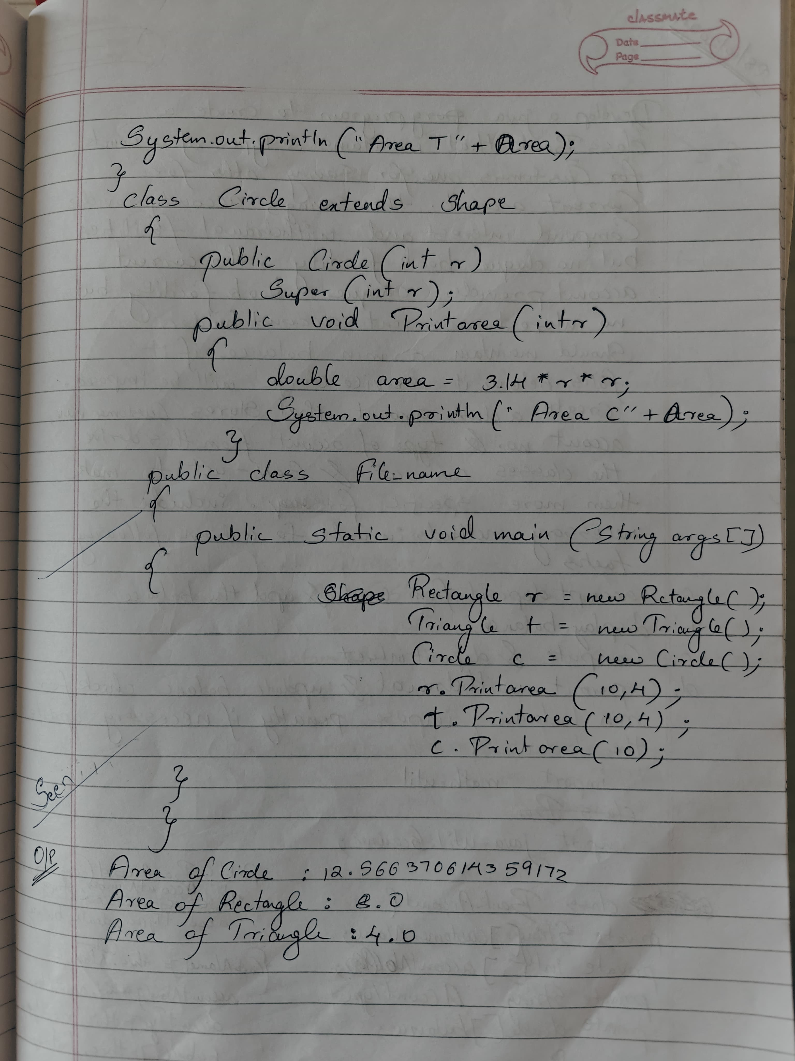

CODE:

// Abstract class Shape

abstract class Shape {

int dimension1;

int dimension2;

// Abstract method to calculate and print the area

abstract void printArea();

}

// Rectangle class extending Shape

class Rectangle extends Shape {

Rectangle(int length, int breadth) {

this.dimension1 = length;

this.dimension2 = breadth;

}

@Override

void printArea() {

int area = dimension1 * dimension2;

System.out.println("Area of Rectangle: " + area);

}

}

// Triangle class extending Shape

class Triangle extends Shape {

Triangle(int base, int height) {

this.dimension1 = base;

this.dimension2 = height;

}

@Override

void printArea() {

double area = 0.5 * dimension1 * dimension2;

System.out.println("Area of Triangle: " + area);

}

}

// Circle class extending Shape

class Circle extends Shape {

Circle(int radius) {

this.dimension1 = radius;

this.dimension2 = 0; // Not required for a circle

}

@Override

void printArea() {

double area = Math.PI * dimension1 * dimension1;

System.out.println("Area of Circle: " + area);

}

}

// Main class to test the functionality

public class Main {

public static void main(String[] args) {

// Create objects for each shape

Shape rectangle = new Rectangle(10, 5);

Shape triangle = new Triangle(6, 8);

Shape circle = new Circle(7);

// Print areas of the shapes

rectangle.printArea();

triangle.printArea();

circle.printArea();

System.out.println("NAME: Danish");

System.out.println("USN: 1BM23CS086");

}

}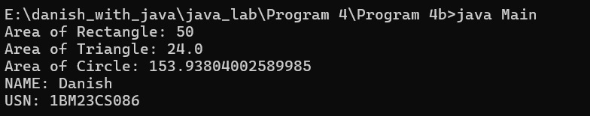

**PROGRAM 5**

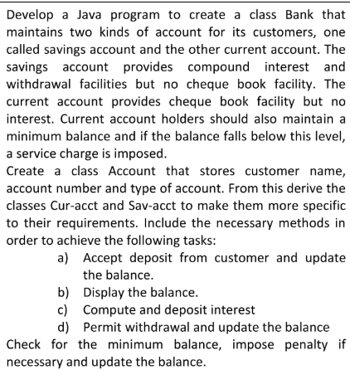

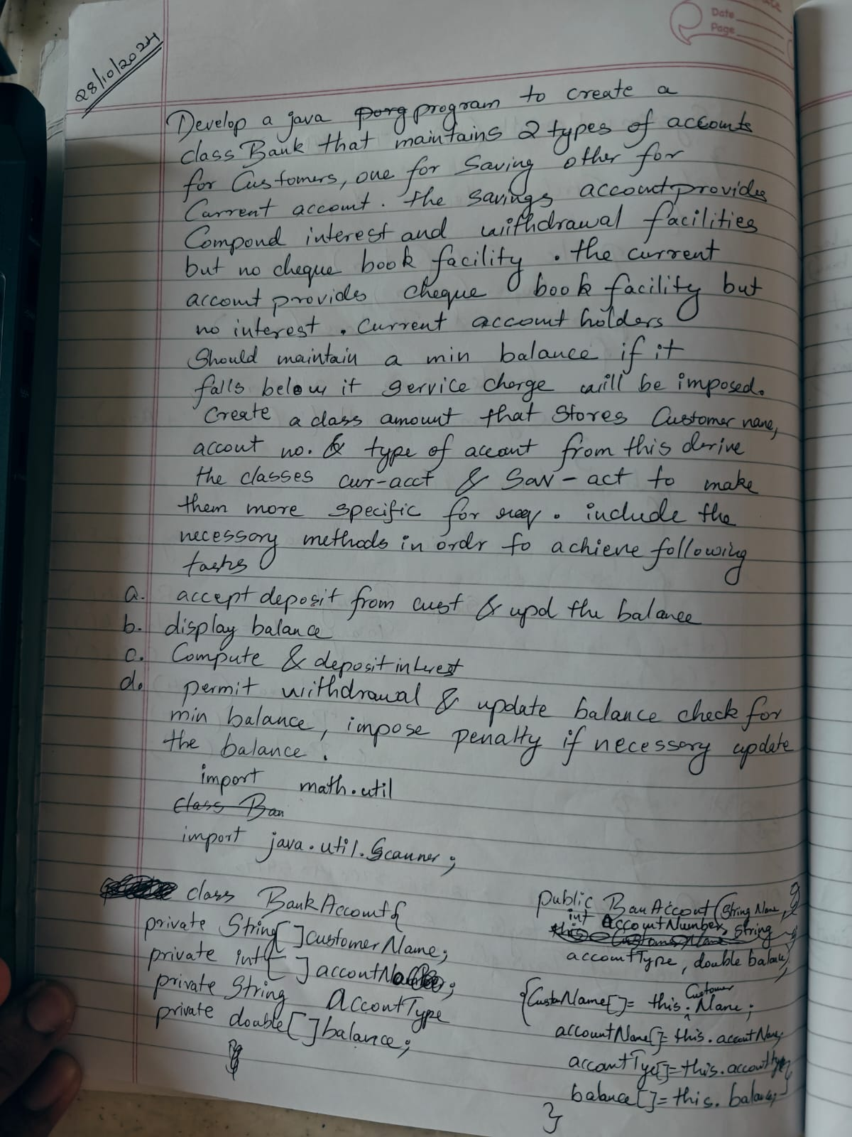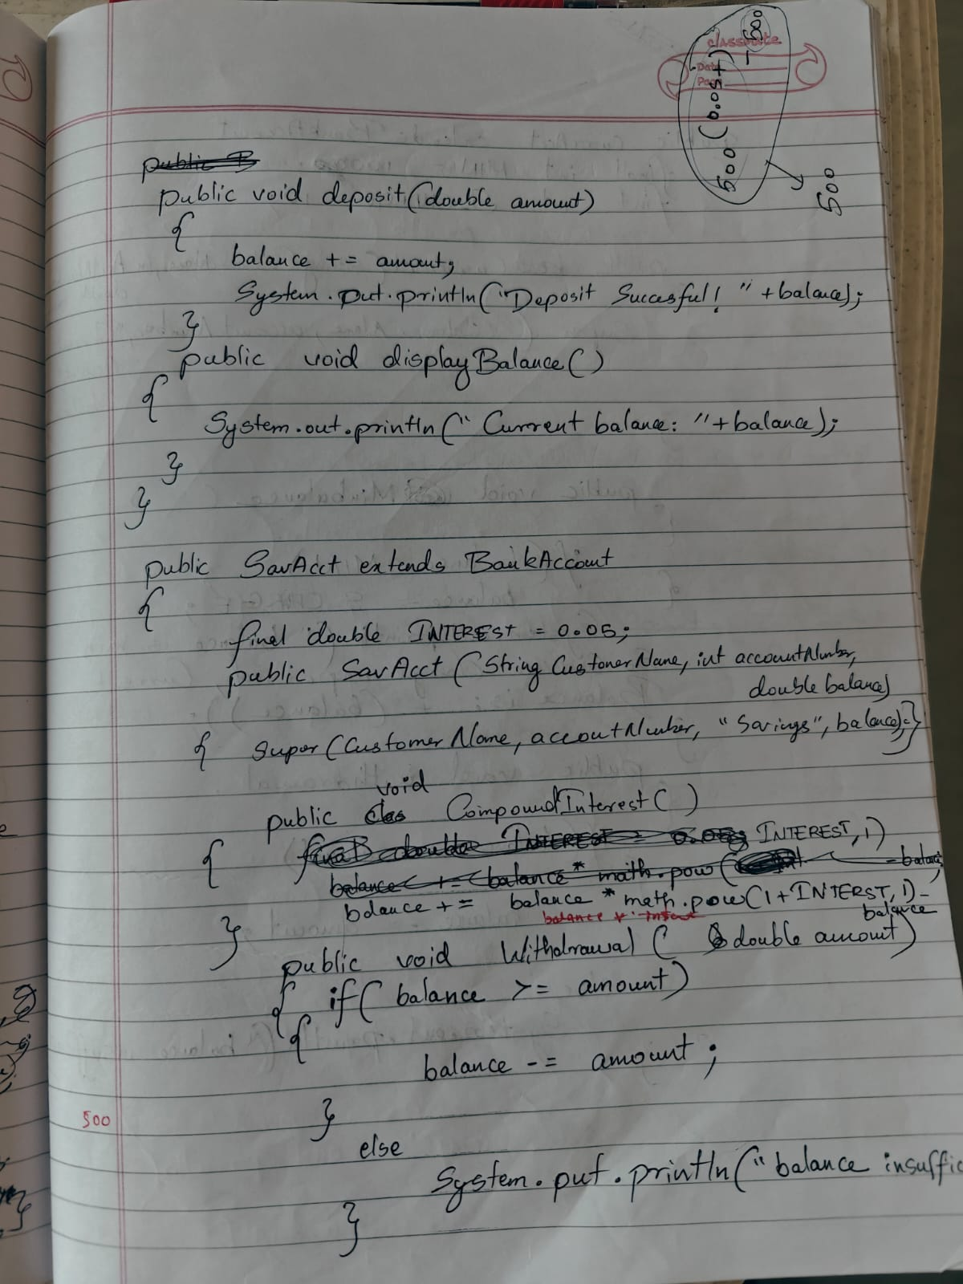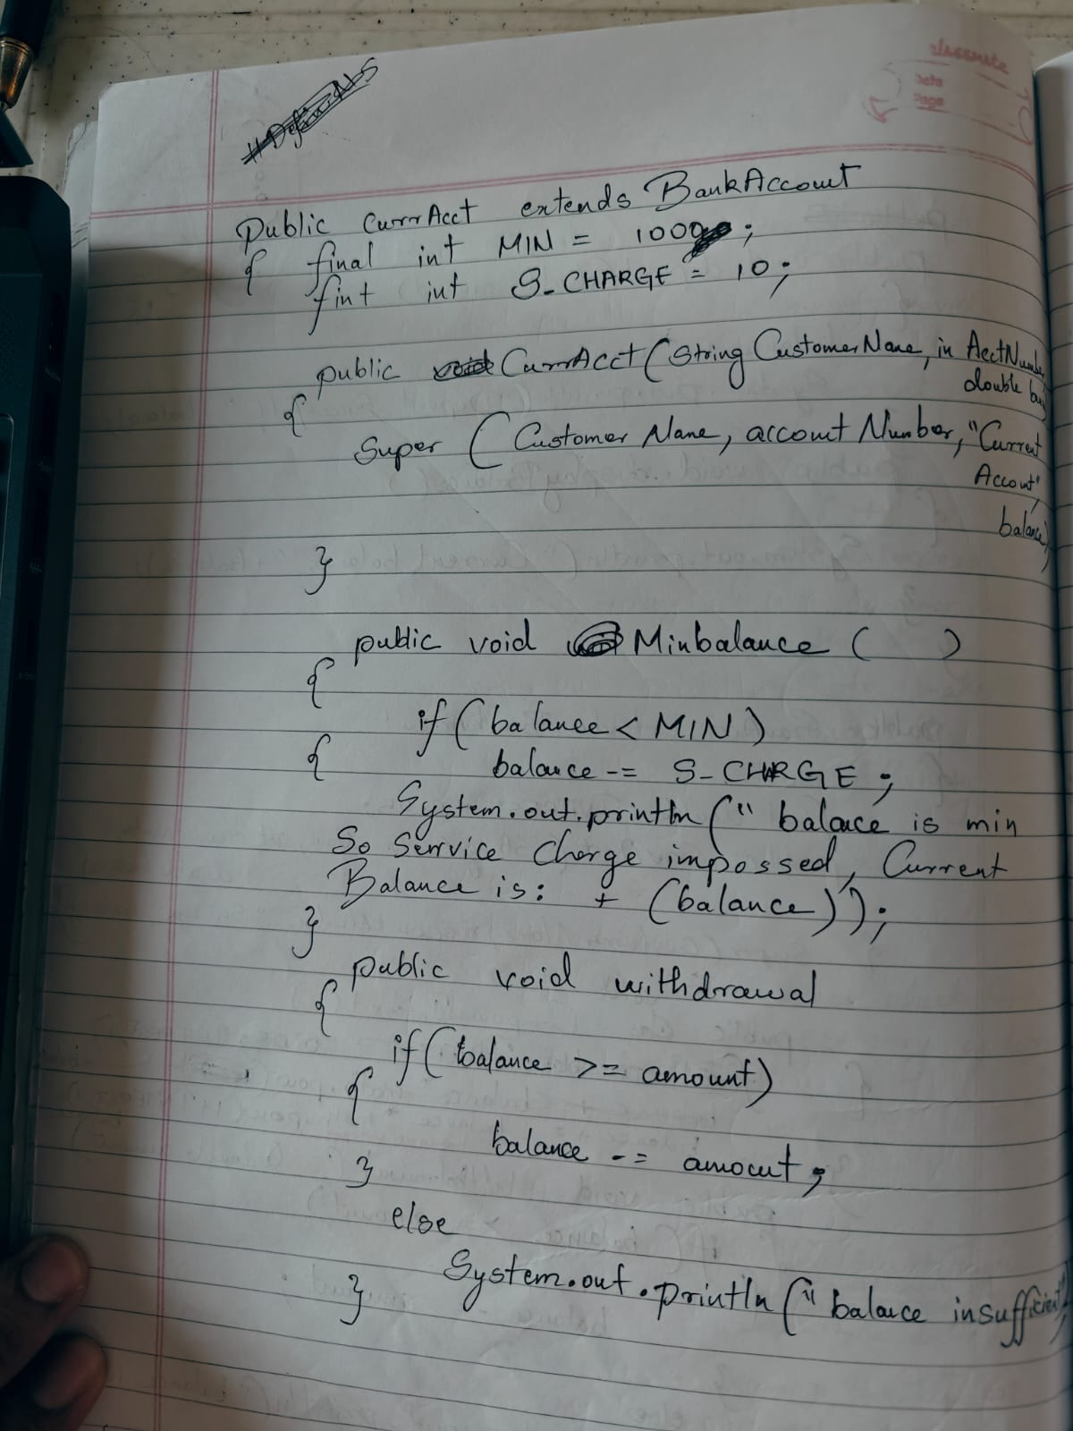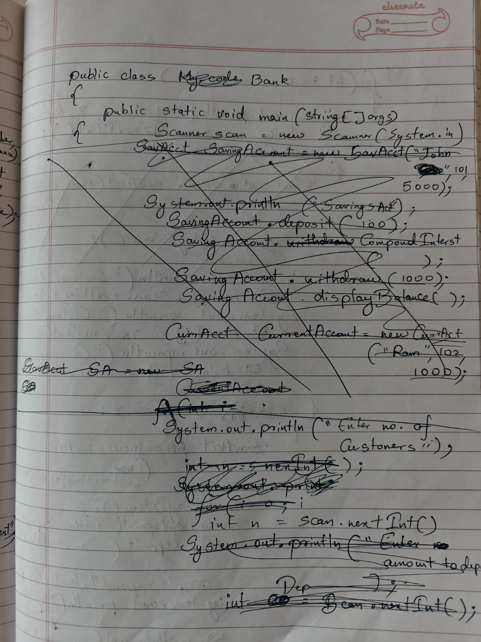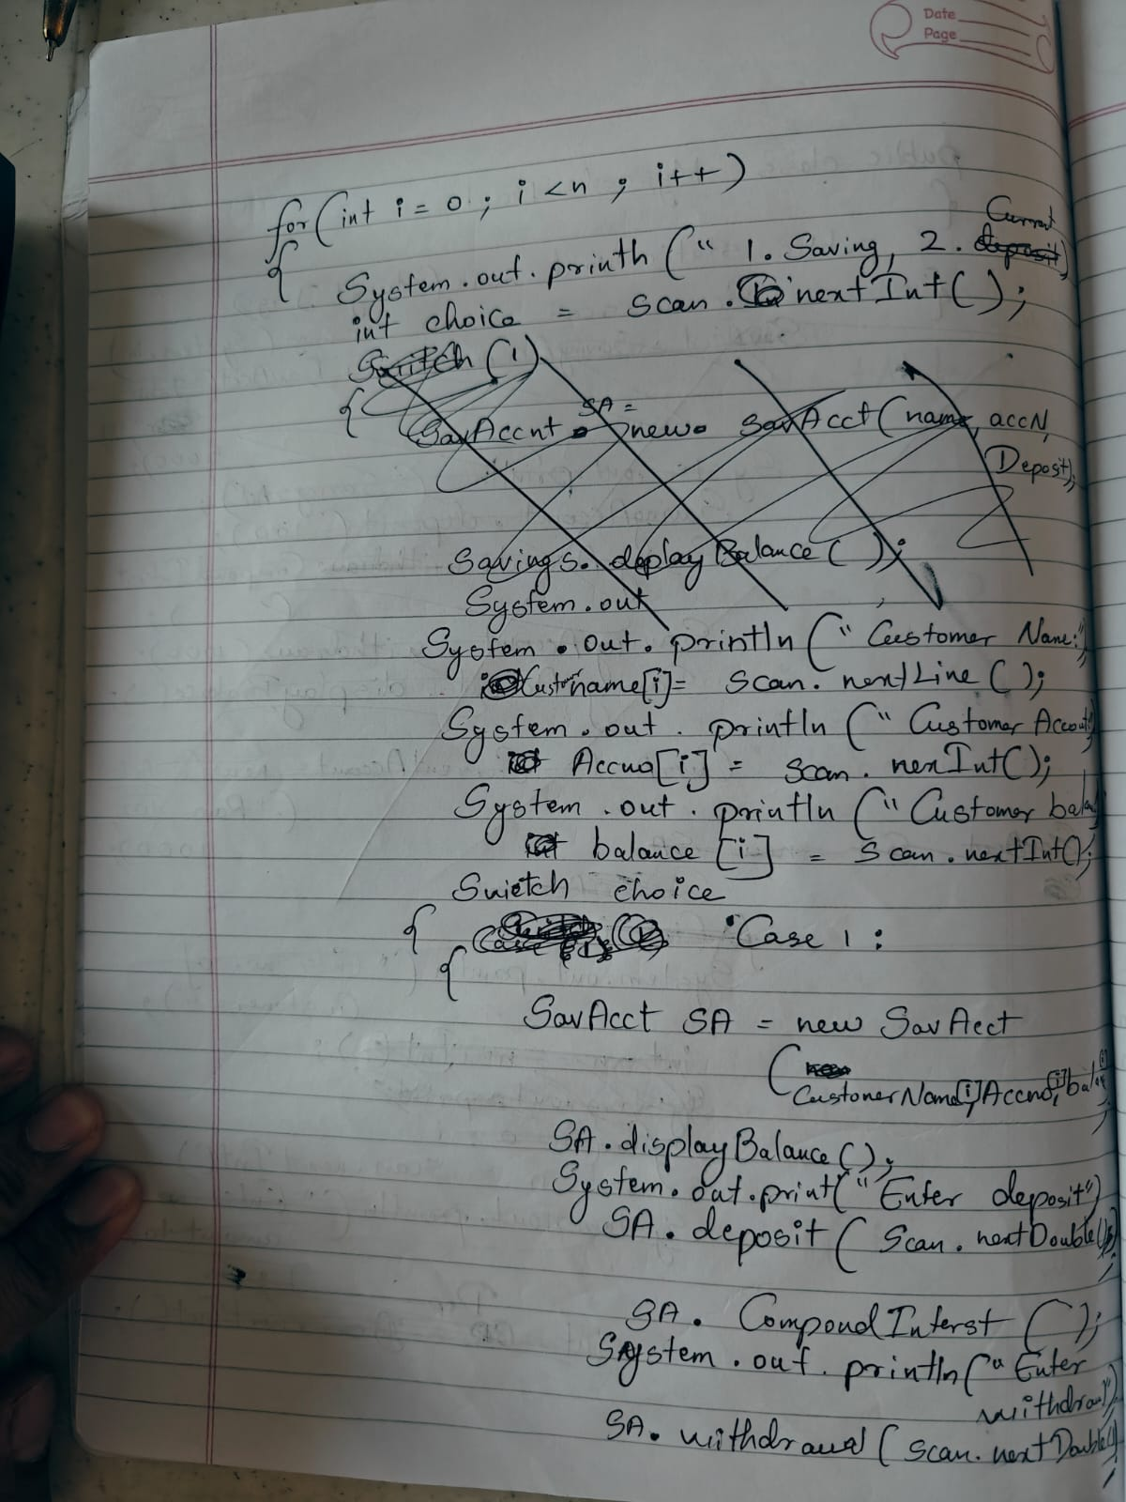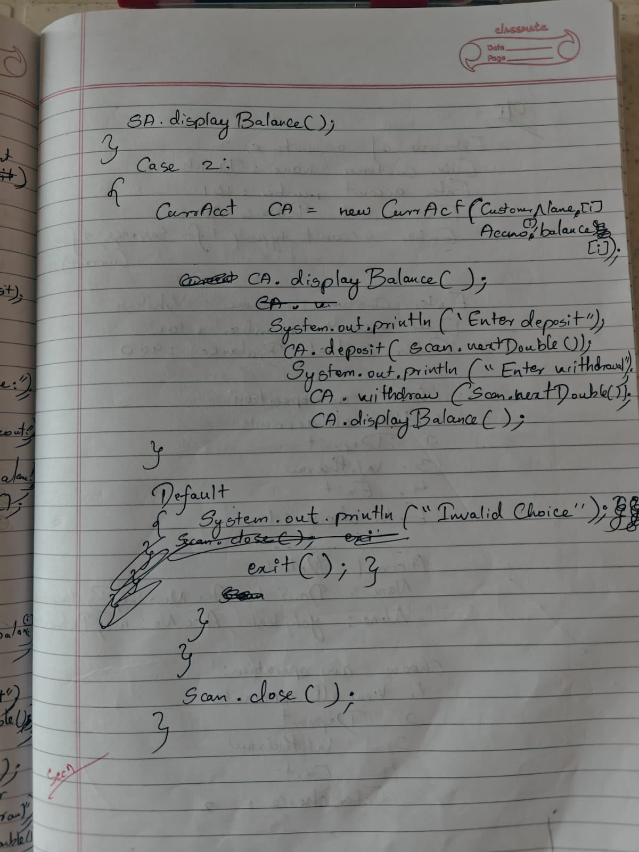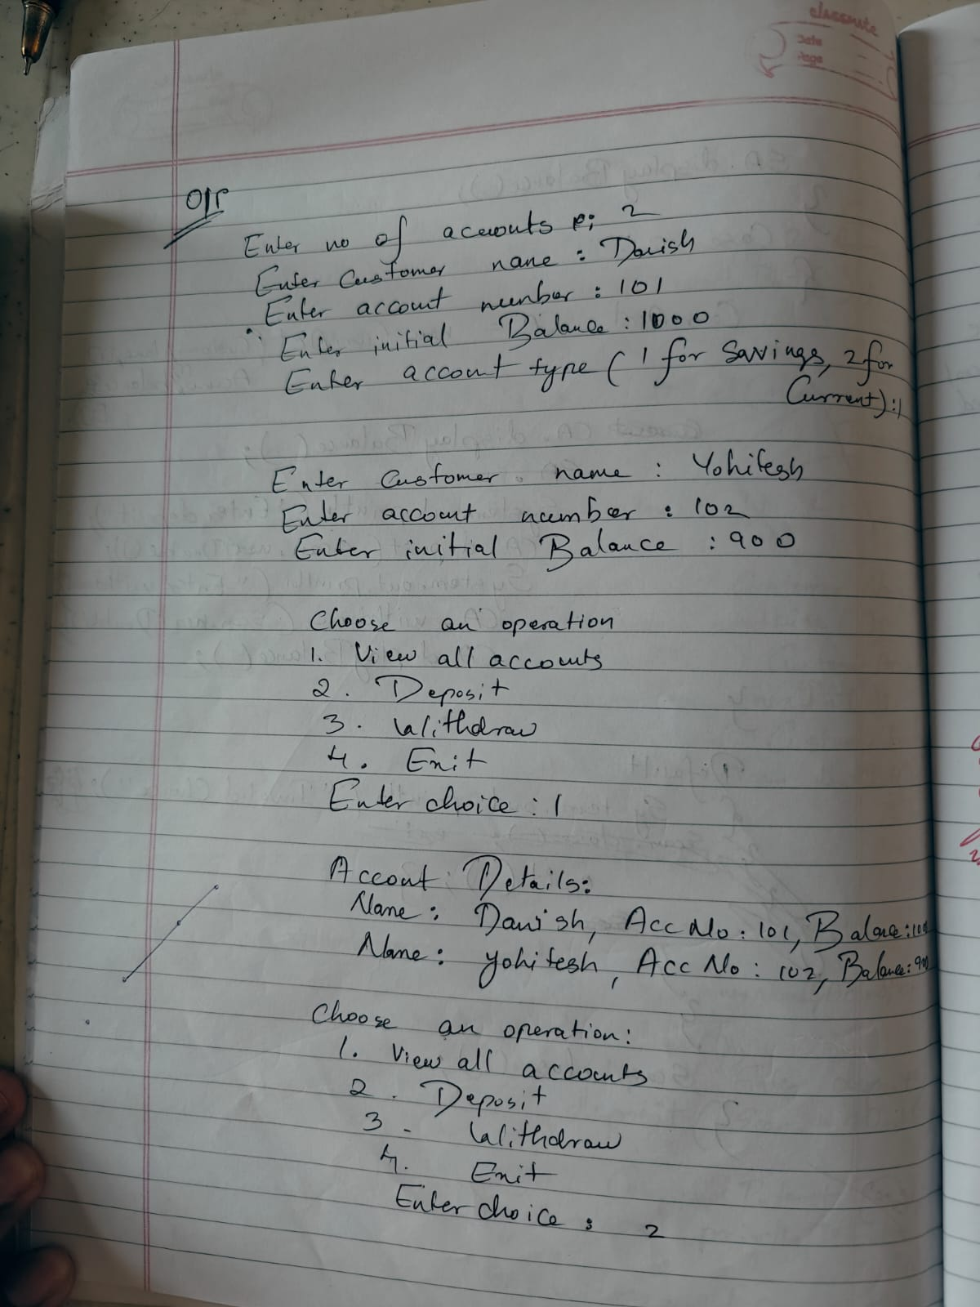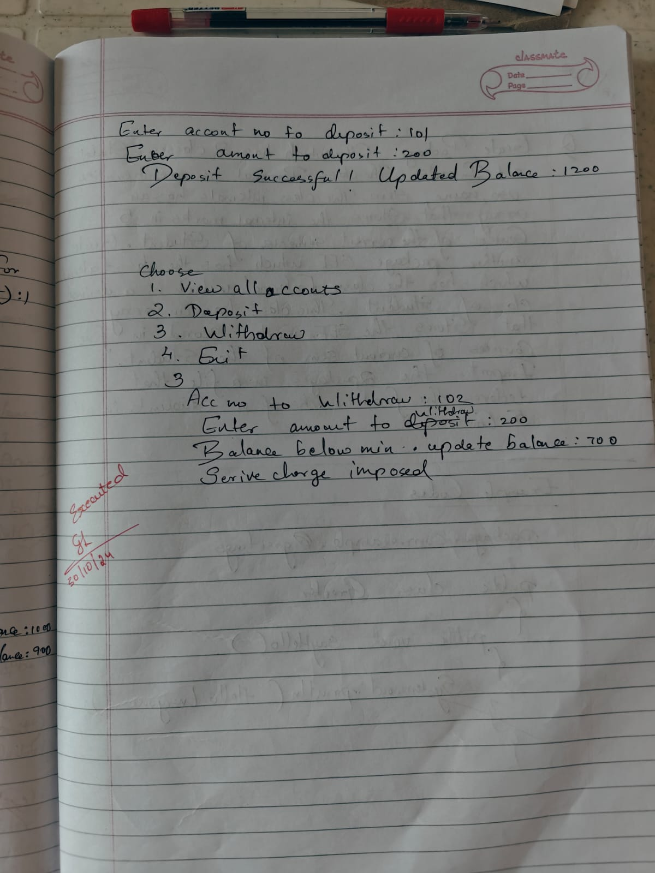

CODE:

import java.util.Scanner;

class BankAccount {

    String customerName;

    int accountNumber;

    String accountType;

    double balance;

    public BankAccount(String customerName, int accountNumber, String accountType, double balance) {

        this.customerName = customerName;

        this.accountNumber = accountNumber;

        this.accountType = accountType;

        this.balance = balance;

    }

    public void deposit(double amount) {

        balance += amount;

        System.out.println("Deposit successful! Updated balance: " + balance);

    }

    public void displayBalance() {

        System.out.println("Current balance: " + balance);

    }

}

class SavAcct extends BankAccount {

    final double INTEREST_RATE = 0.04; // 4% interest rate

    public SavAcct(String customerName, int accountNumber, double balance) {

        super(customerName, accountNumber, "Savings", balance);

    }

    public void computeAndDepositInterest() {

        double interest = balance * Math.pow(1 + INTEREST_RATE, 1) - balance;

        balance += interest;

        System.out.println("Interest added! Updated balance: " + balance);

    }

    public void withdraw(double amount) {

        if (balance >= amount) {

            balance -= amount;

            System.out.println("Withdrawal successful! Updated balance: " + balance);

        } else {

            System.out.println("Insufficient balance!");

        }

    }

}

class CurAcct extends BankAccount {

    final double MIN_BALANCE = 1000.0;

    final double SERVICE_CHARGE = 100.0;

    public CurAcct(String customerName, int accountNumber, double balance) {

        super(customerName, accountNumber, "Current", balance);

    }

    public void checkMinBalance() {

        if (balance < MIN_BALANCE) {

            balance -= SERVICE_CHARGE;

            System.out.println("Balance below minimum! Service charge imposed. Updated balance: " + balance);

        }

    }

    public void withdraw(double amount) {

        if (balance >= amount) {

            balance -= amount;

            checkMinBalance();

            System.out.println("Withdrawal successful! Updated balance: " + balance);

        } else {

            System.out.println("Insufficient balance!");

        }

    }

}

public class Bank {

    public static void main(String[] args) {

        Scanner scanner = new Scanner(System.in);

        SavAcct savingsAccount = new SavAcct("John Doe", 101, 5000.0);

        System.out.println("\nSavings Account:");

        savingsAccount.deposit(1000);

        savingsAccount.computeAndDepositInterest();

        savingsAccount.withdraw(2000);

        savingsAccount.displayBalance();

        CurAcct currentAccount = new CurAcct("Jane Doe", 102, 1200.0);

        System.out.println("\nCurrent Account:");

        currentAccount.deposit(500);

        currentAccount.withdraw(100);

        currentAccount.withdraw(2000);

        currentAccount.displayBalance();

        scanner.close();

        System.out.println("Name:Danish \nUSN:1BM23CS086");

    }

}

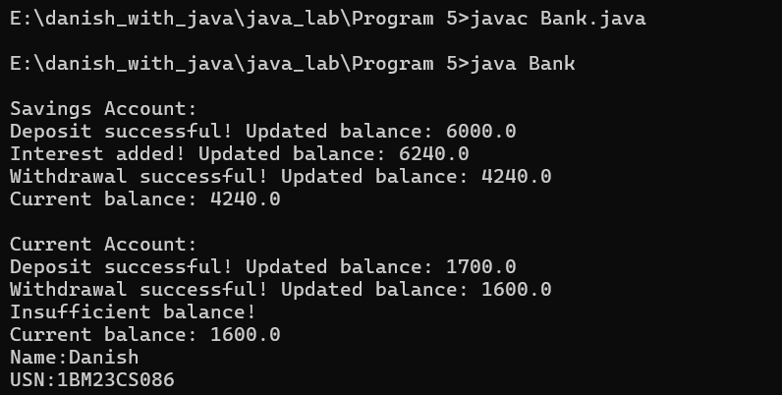

**PROGRAM 6**

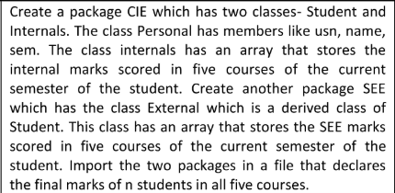

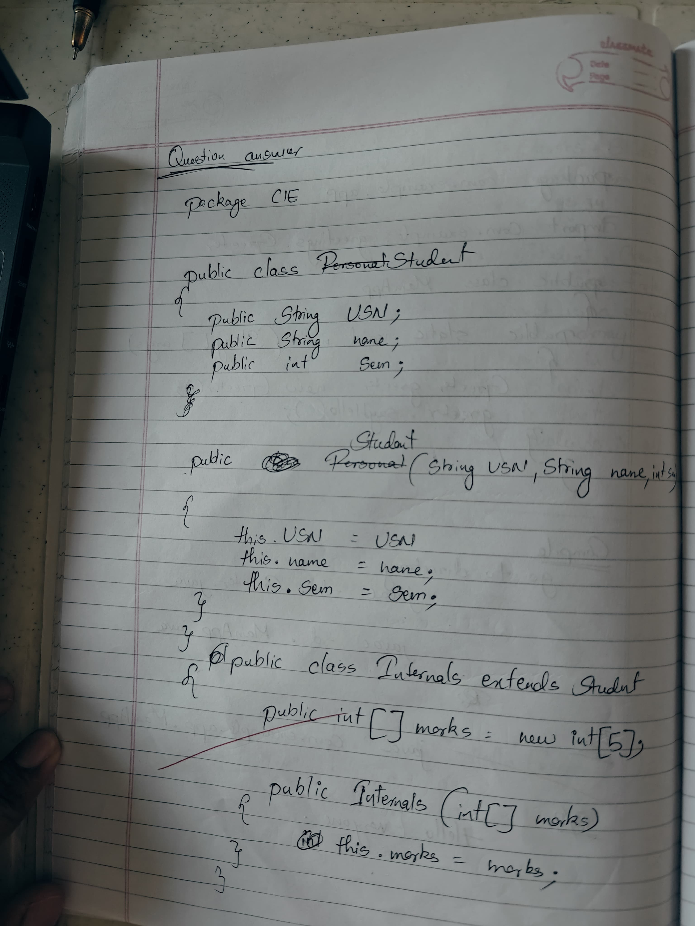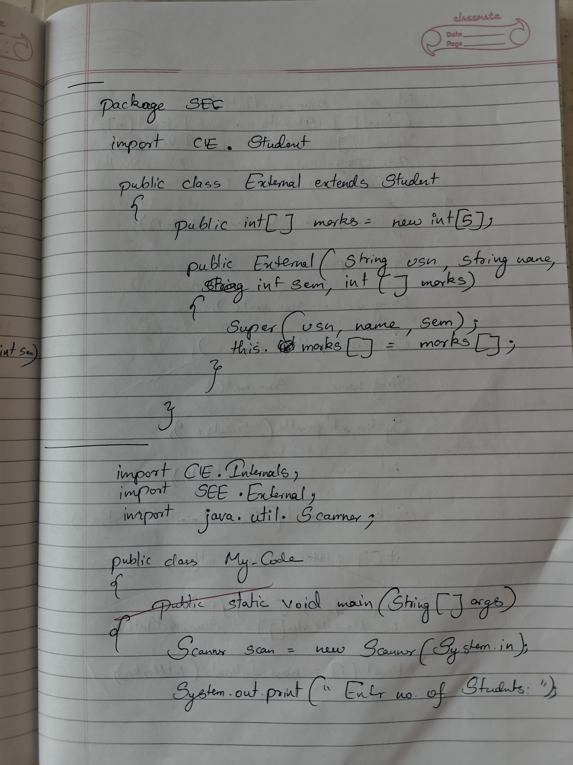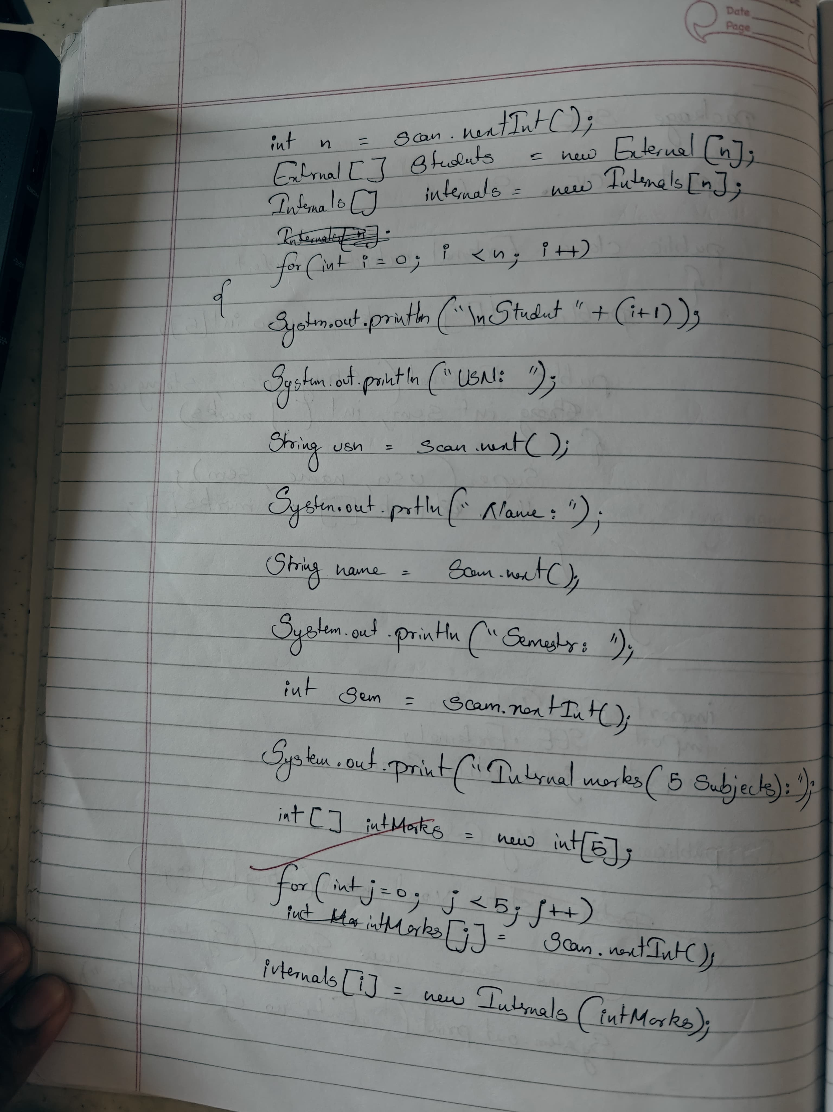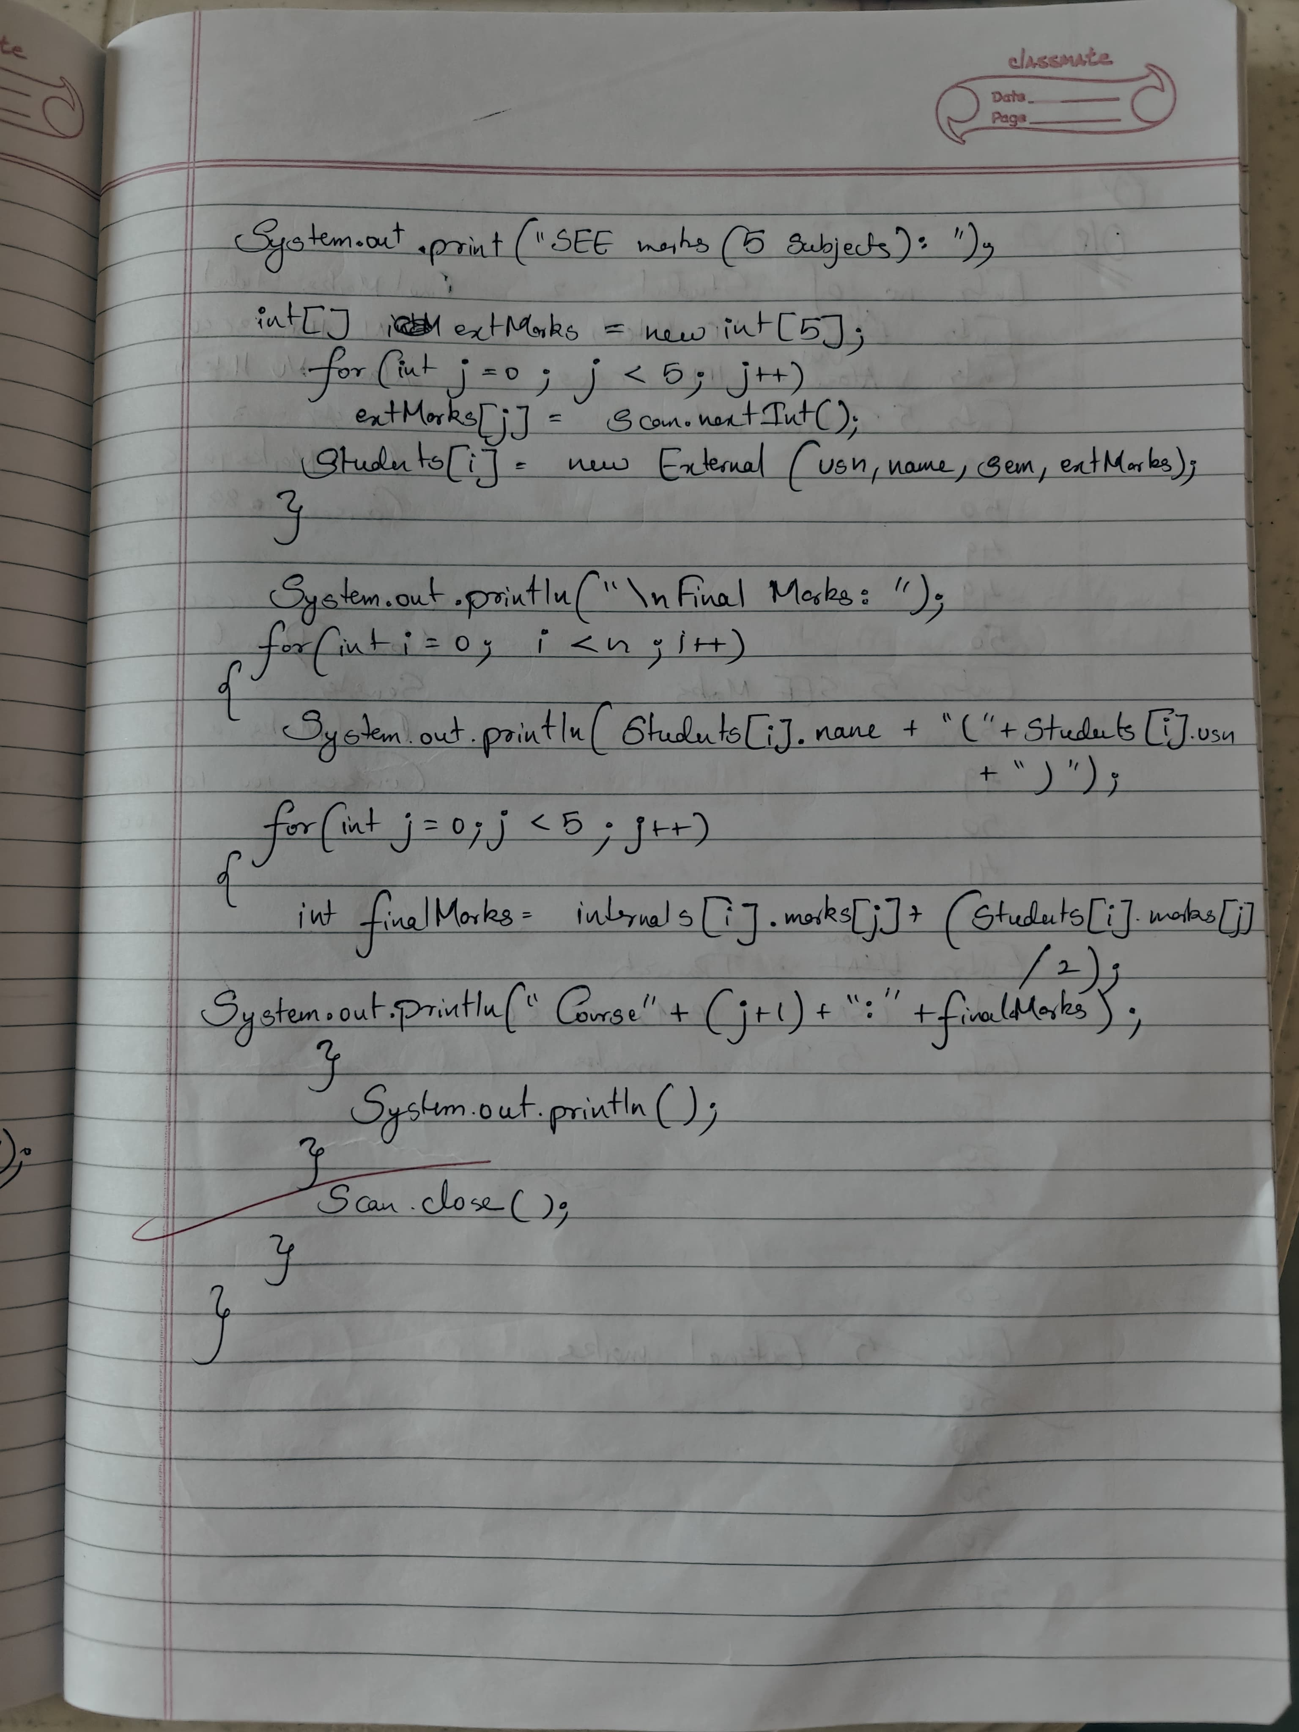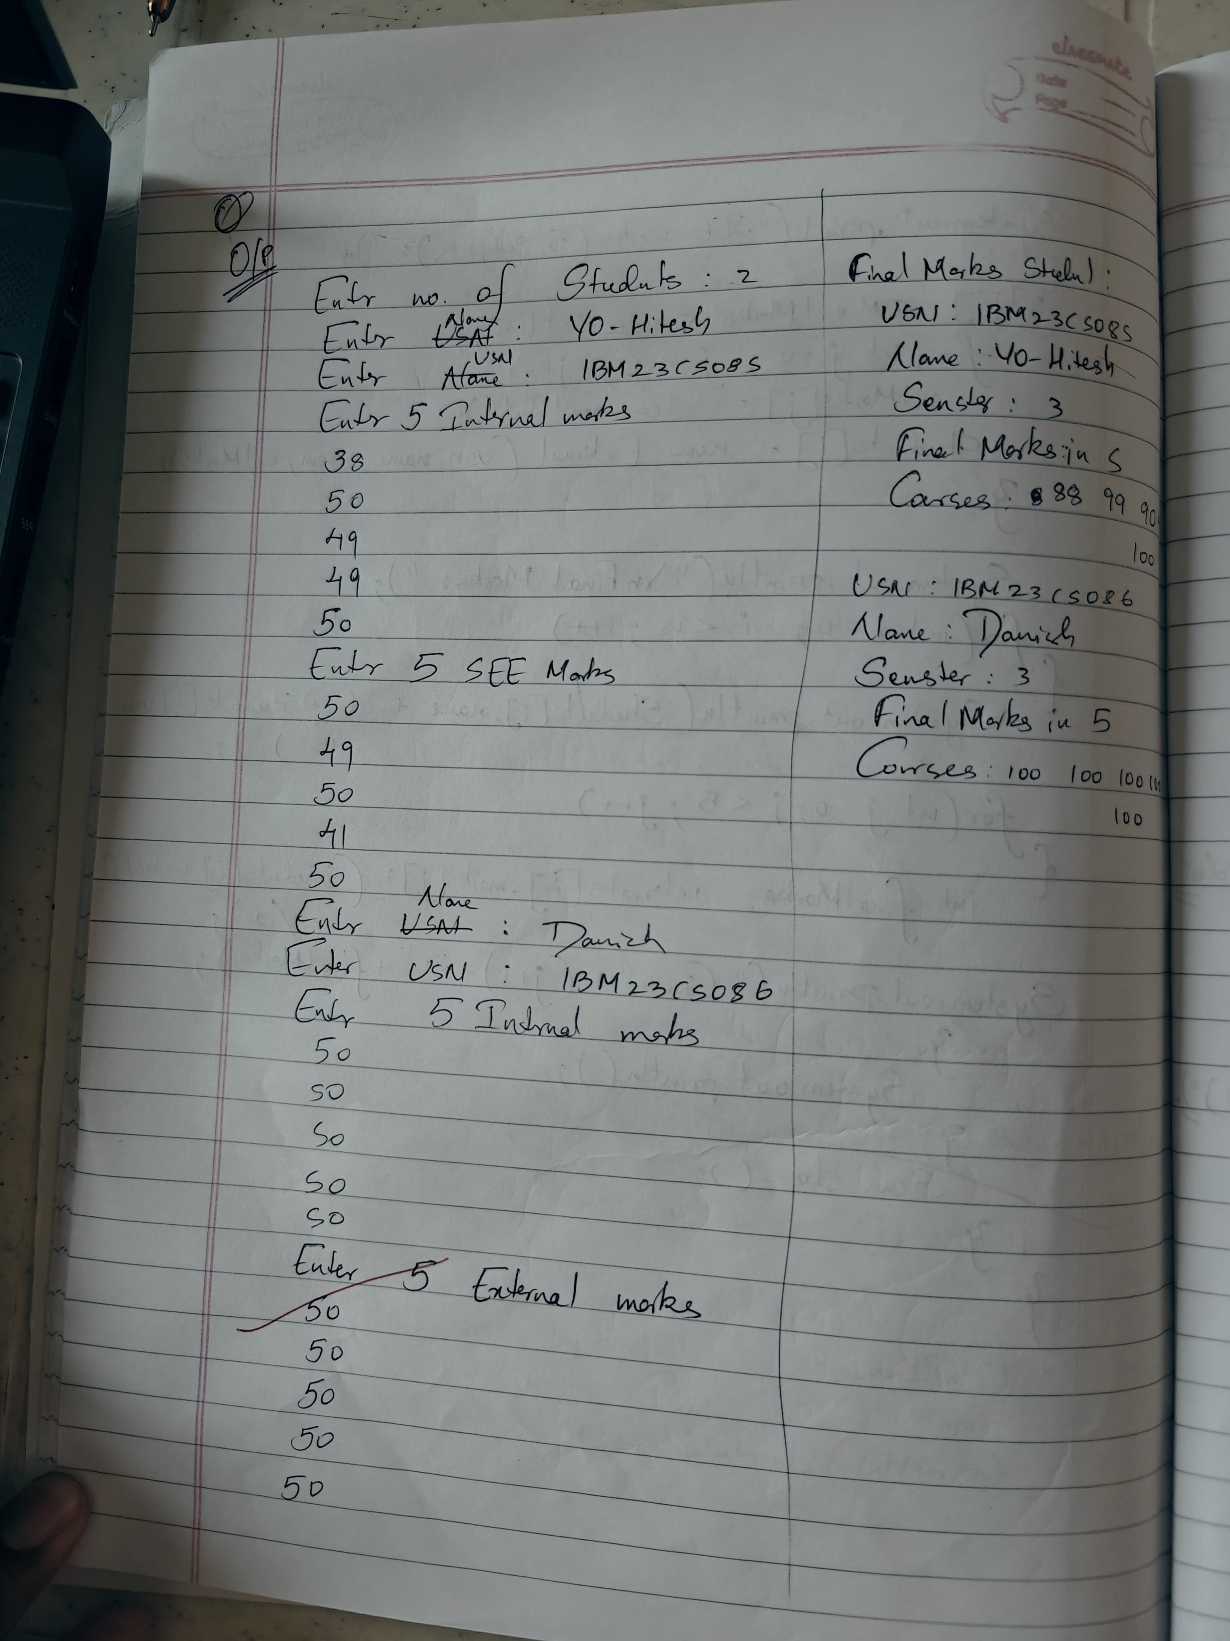

CODE:

**Personal.java**

package CIE;

public class Personal

{

 public String USN;

 public String name;

 public int sem;

public Personal(String USN,String name,int sem)

{

 this.USN = USN;

 this.name = name;

 this.sem = sem;

}

}

**Internals.java**

package CIE;

public class Internals extends Personal {

    public int[] internalMarks = new int[5];

    public Internals(String usn, String name, int sem, int[] internalMarks) {

        super(usn, name, sem);

        this.internalMarks = internalMarks;

    }

}

**Externals.java**

package SEE;

import CIE.Personal;

public class External extends Personal {

    public int[] seeMarks;

    // Constructor to initialize the SEE marks

    public External(String usn, String name, int sem, int[] seeMarks) {

        super(usn, name, sem);

        this.seeMarks = seeMarks;

    }

}

**Marks.java**

import CIE.Internals;

import SEE.External;

import java.util.Scanner;

public class Marks {

    public static void main(String[] args) {

        Scanner sc = new Scanner(System.in);

        System.out.print("Enter the number of students: ");

        int n = sc.nextInt();

        Internals[] internalStudents = new Internals[n];

        External[] externalStudents = new External[n];

        for (int i = 0; i < n; i++) {

            sc.nextLine(); // Clear the buffer

            System.out.print("Enter USN: ");

            String usn = sc.nextLine();

            System.out.print("Enter Name: ");

            String name = sc.nextLine();

            System.out.print("Enter Semester: ");

            int sem = sc.nextInt();

            int[] internalMarks = new int[5]; // Assuming 5 internal marks for simplicity

            System.out.println("Enter 5 internal marks:");

            for (int j = 0; j < 5; j++) {

                internalMarks[j] = sc.nextInt();

            }

            internalStudents[i] = new Internals(usn, name, sem, internalMarks);

            int[] seeMarks = new int[5]; // Assuming 5 SEE marks

            System.out.println("Enter 5 SEE marks:");

            for (int j = 0; j < 5; j++) {

                seeMarks[j] = sc.nextInt();

            }

            externalStudents[i] = new External(usn, name, sem, seeMarks);

        }

        System.out.println("\nFinal Marks:");

        for (int i = 0; i < n; i++) {

            System.out.println("Student " + (i + 1) + ":");

            System.out.println("USN: " + internalStudents[i].USN);

            System.out.println("Name: " + internalStudents[i].name);

            System.out.println("Semester: " + internalStudents[i].sem);

            System.out.print("Final Marks in 5 Courses: ");

            for (int j = 0; j < 5; j++) {

                // Calculate final mark for each course

                int finalMark = internalStudents[i].internalMarks[j] + externalStudents[i].seeMarks[j];

                System.out.print(finalMark + " ");

            }

            System.out.println("\n");

        }

        sc.close();

        System.out.println("Name:Danish \nUSN:1BM23CS086");

    }

}

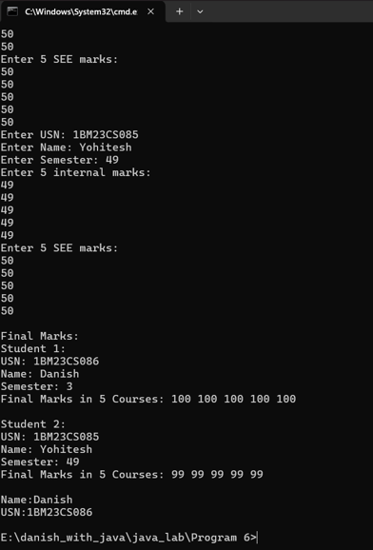

**PROGRAM 7**

Write a Java program to create an interface Polygon with methods getArea() and getPerimeter(). Implement two classes, Rectangle and Circle, to calculate the area and perimeter of a rectangle and a circle. Use a Main class to test these implementations and display the results along with your name and USN.

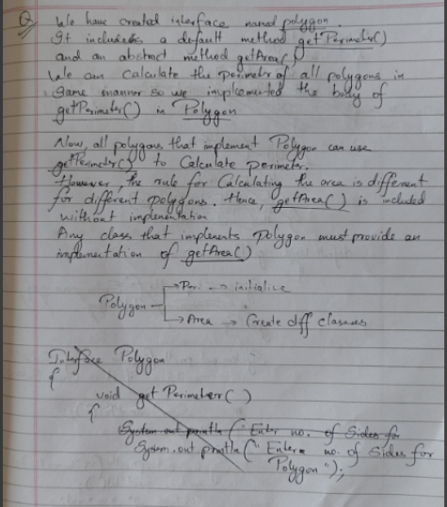

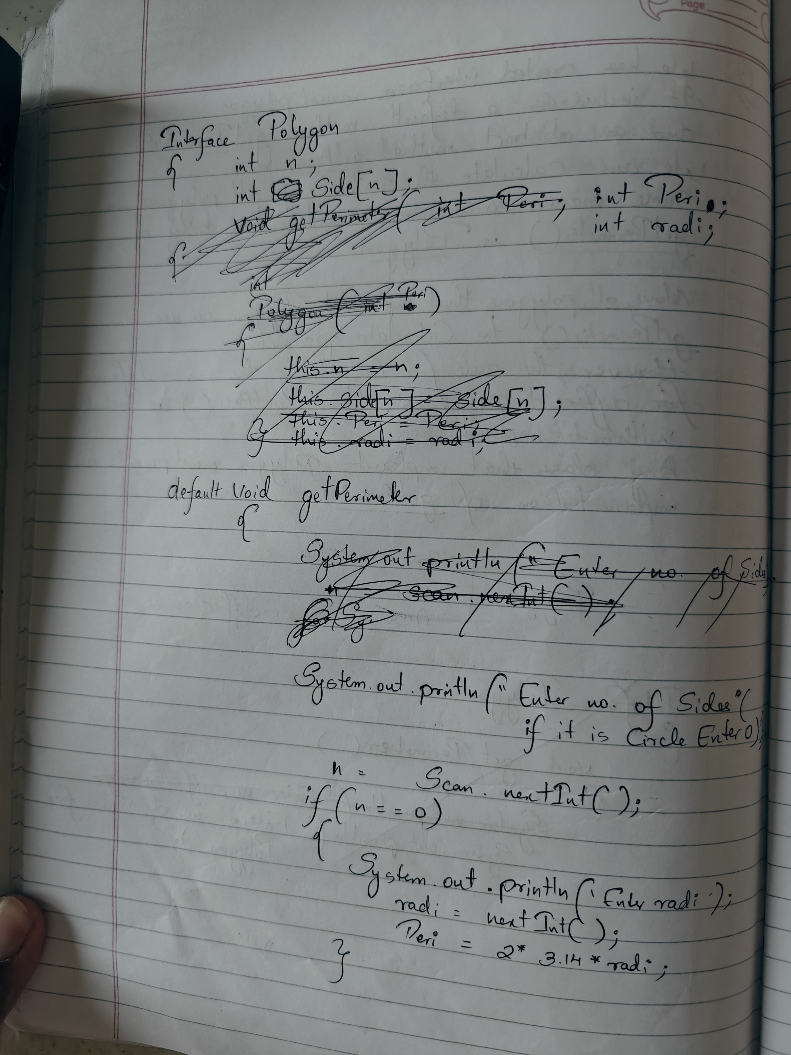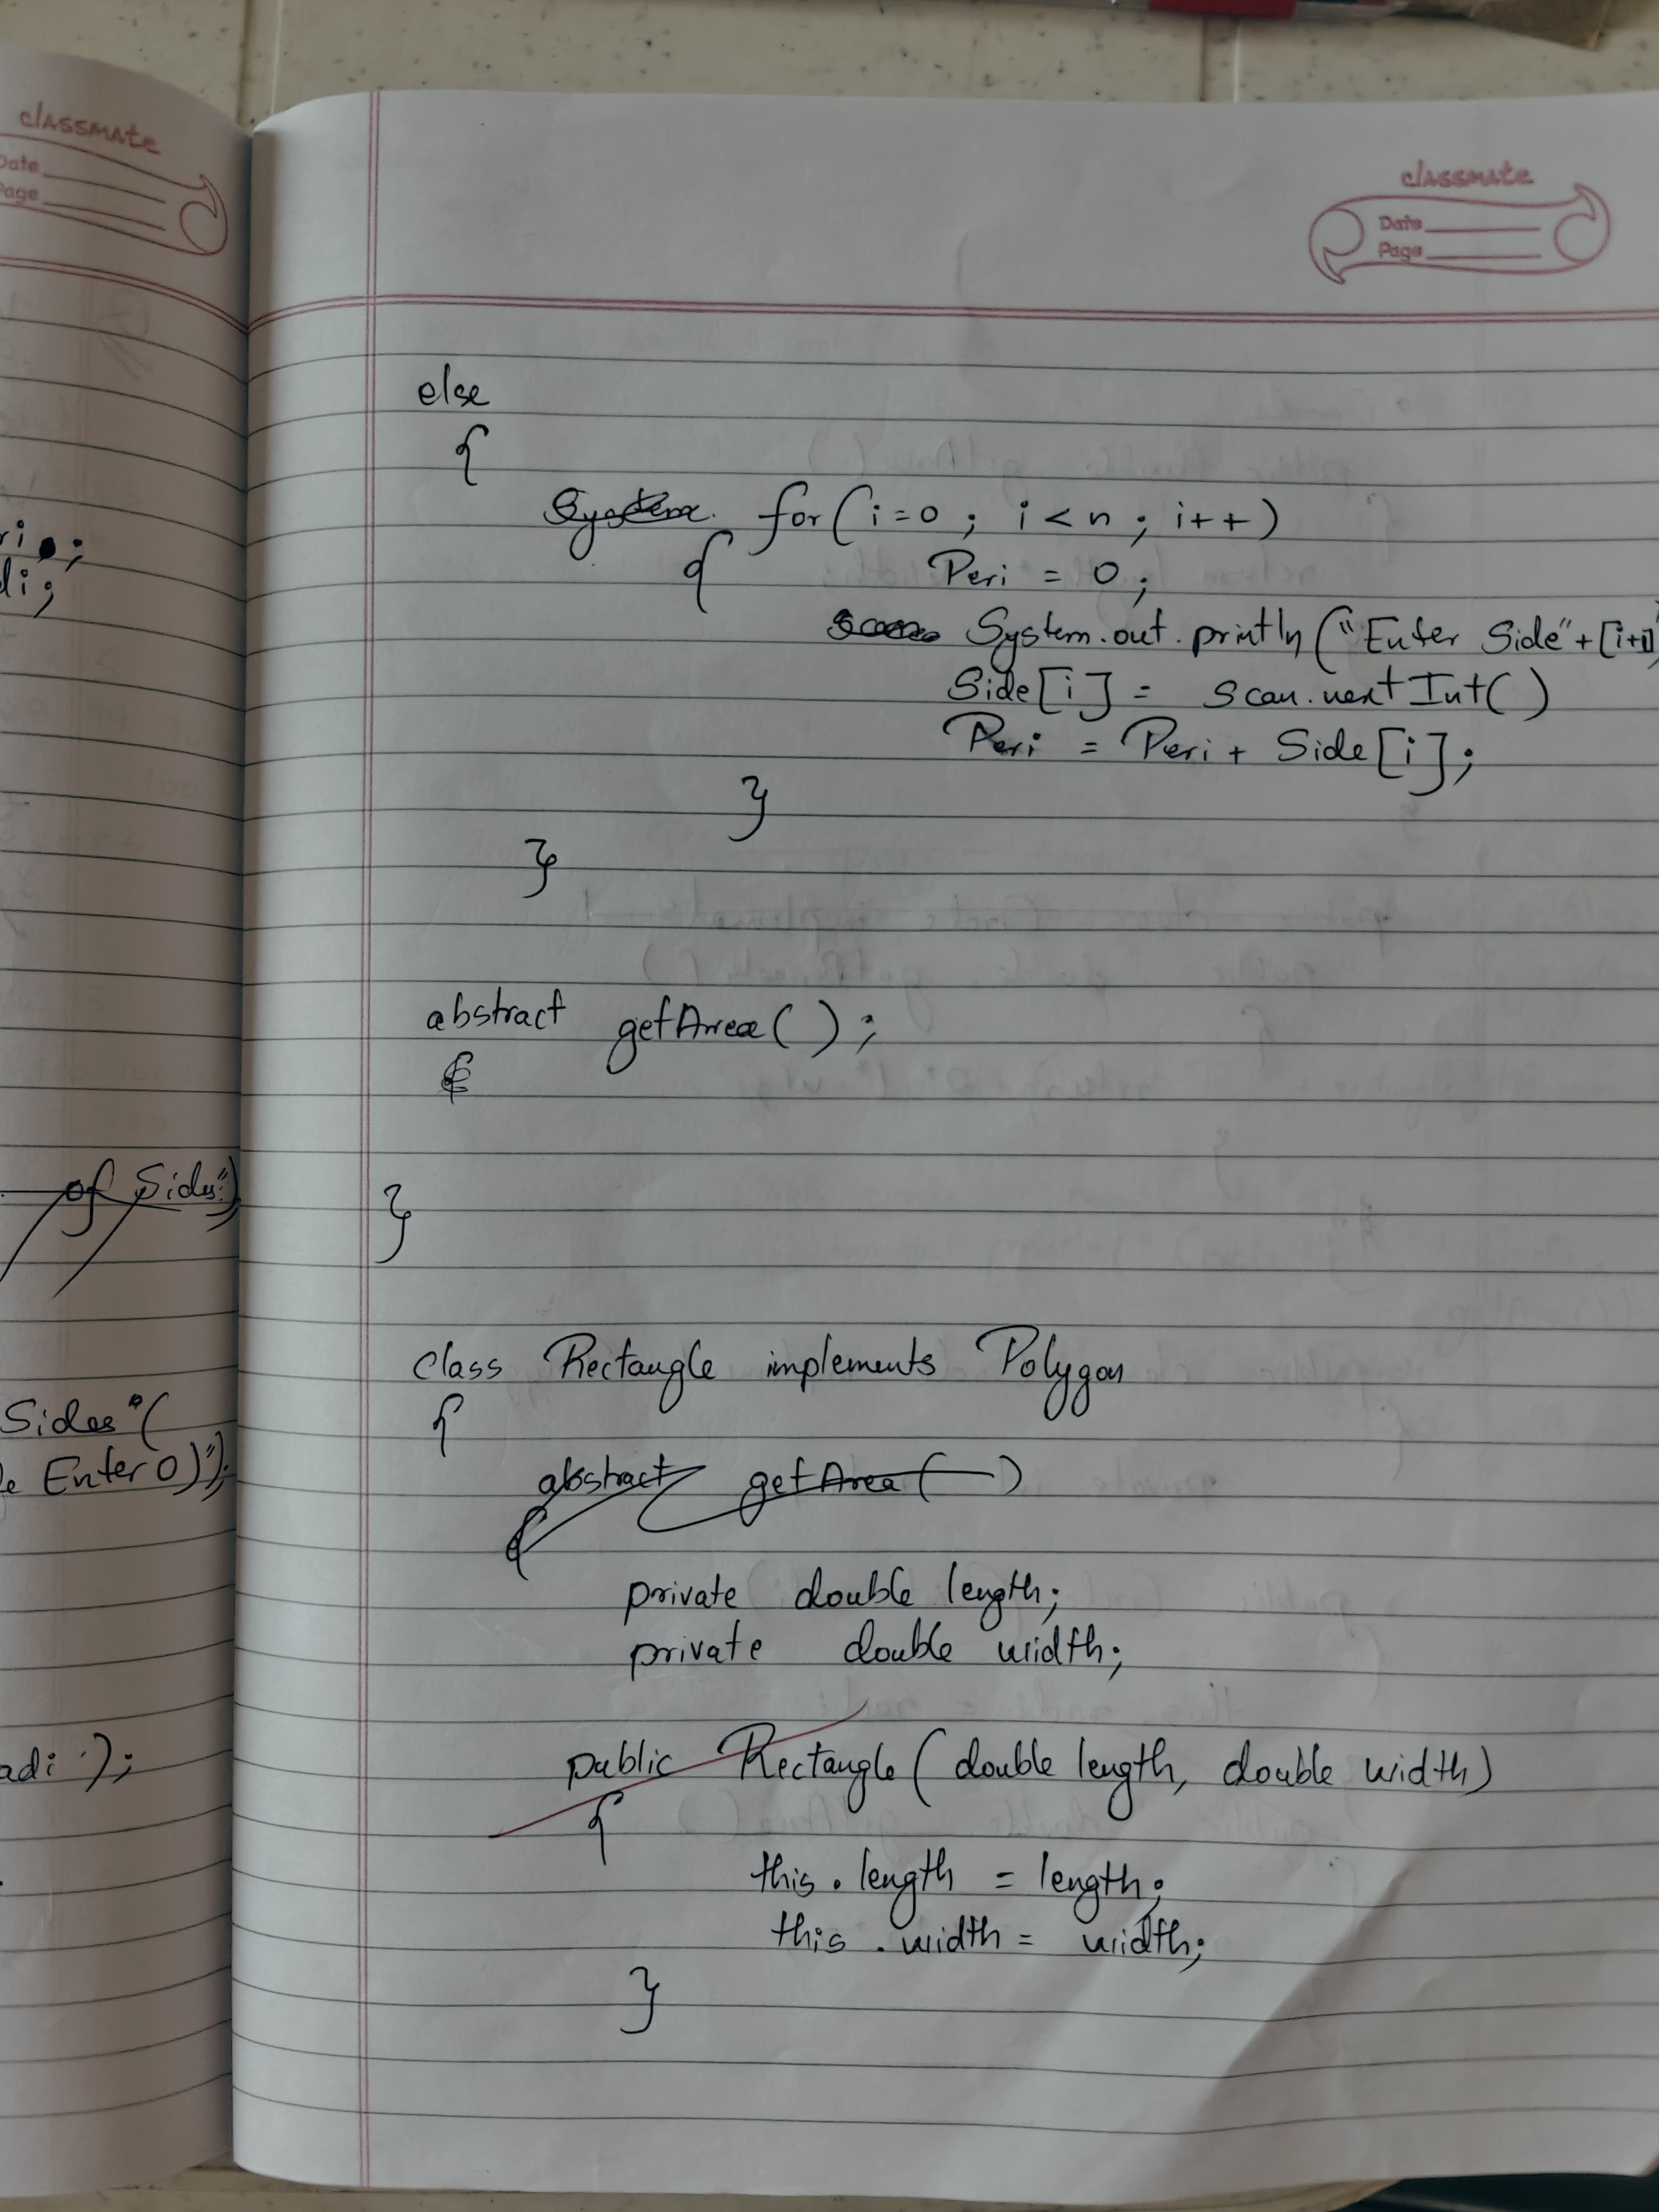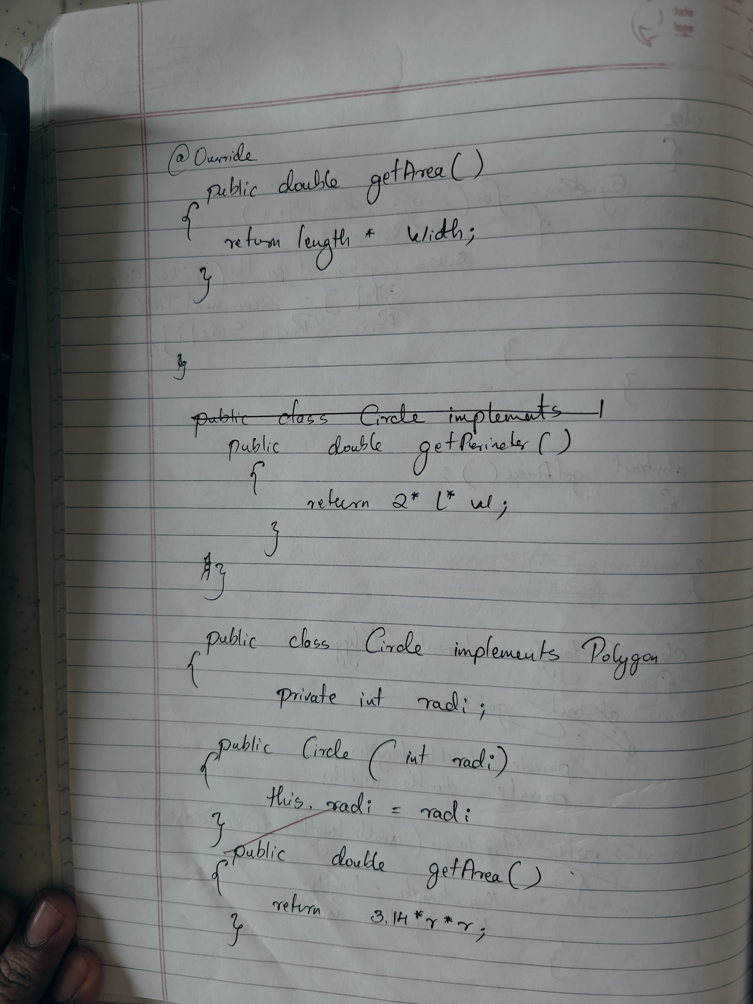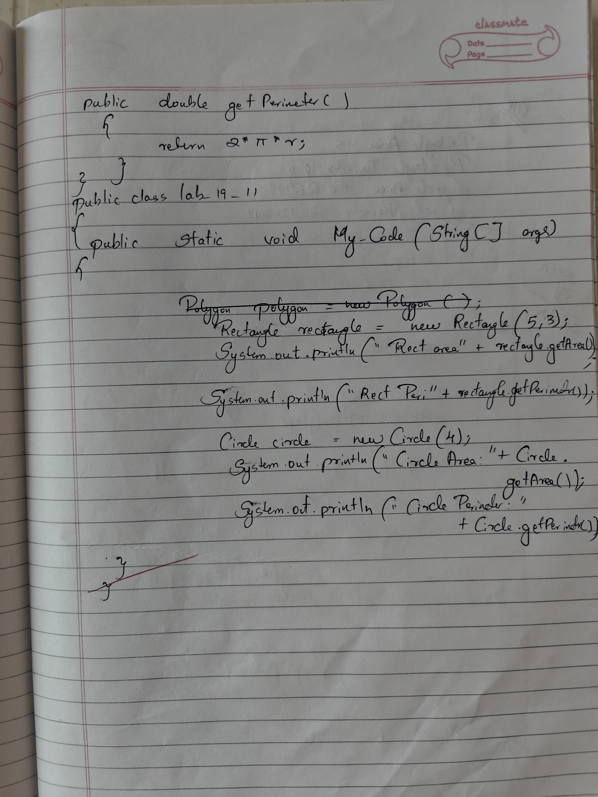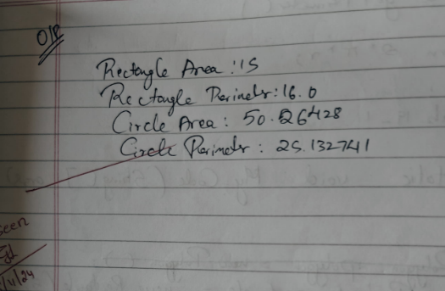

CODE:

**Polygon.java**

// Polygon.java

public interface Polygon {

    default double getPerimeter() {

        return 0.0;

    }

    double getArea();

}

**Circle.java**

// Circle.java

public class Circle implements Polygon {

    private double radius;

    public Circle(double radius) {

        this.radius = radius;

    }

    @Override

    public double getArea() {

        return Math.PI * radius * radius; // Area of circle: π * r^2

    }

    @Override

    public double getPerimeter() {

        return 2 * Math.PI * radius; // Perimeter of circle: 2 * π * r

    }

}

**Rectangle.java**

// Rectangle.java

public class Rectangle implements Polygon {

    private double length;

    private double width;

    public Rectangle(double length, double width) {

        this.length = length;

        this.width = width;

    }

    @Override

    public double getArea() {

        return length * width; // Area of rectangle: length * width

    }

    @Override

    public double getPerimeter() {

        return 2 * (length + width); // Perimeter of rectangle: 2 * (length + width)

    }

}

**Main.java**

// Main.java

public class Main {

    public static void main(String[] args) {

        Rectangle rectangle = new Rectangle(5, 3);

        System.out.println("Rectangle Area: " + rectangle.getArea());

        System.out.println("Rectangle Perimeter: " + rectangle.getPerimeter());

        Circle circle = new Circle(4);

        System.out.println("Circle Area: " + circle.getArea());

        System.out.println("Circle Perimeter: " + circle.getPerimeter());

        System.out.println("Name: Danish \nUSN: 1BM23CS086");

    }

}

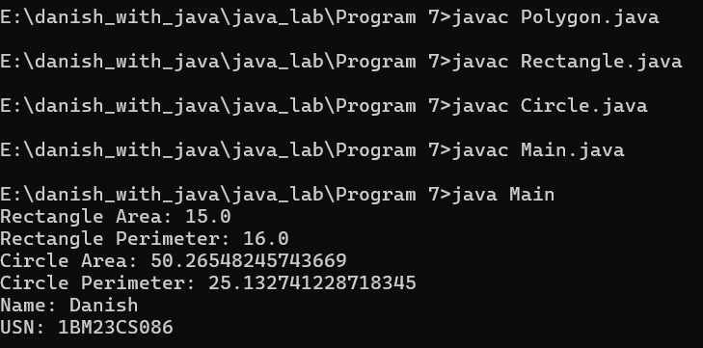

**PROGRAM 8**

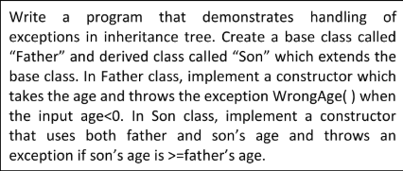

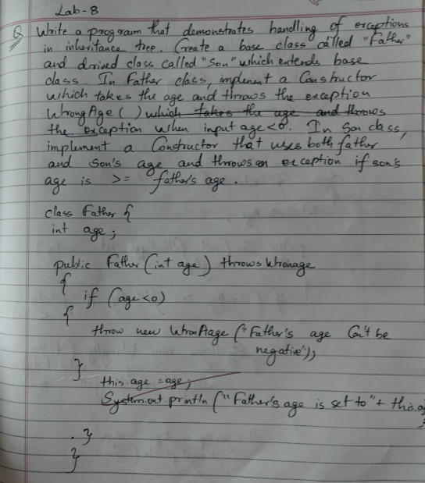

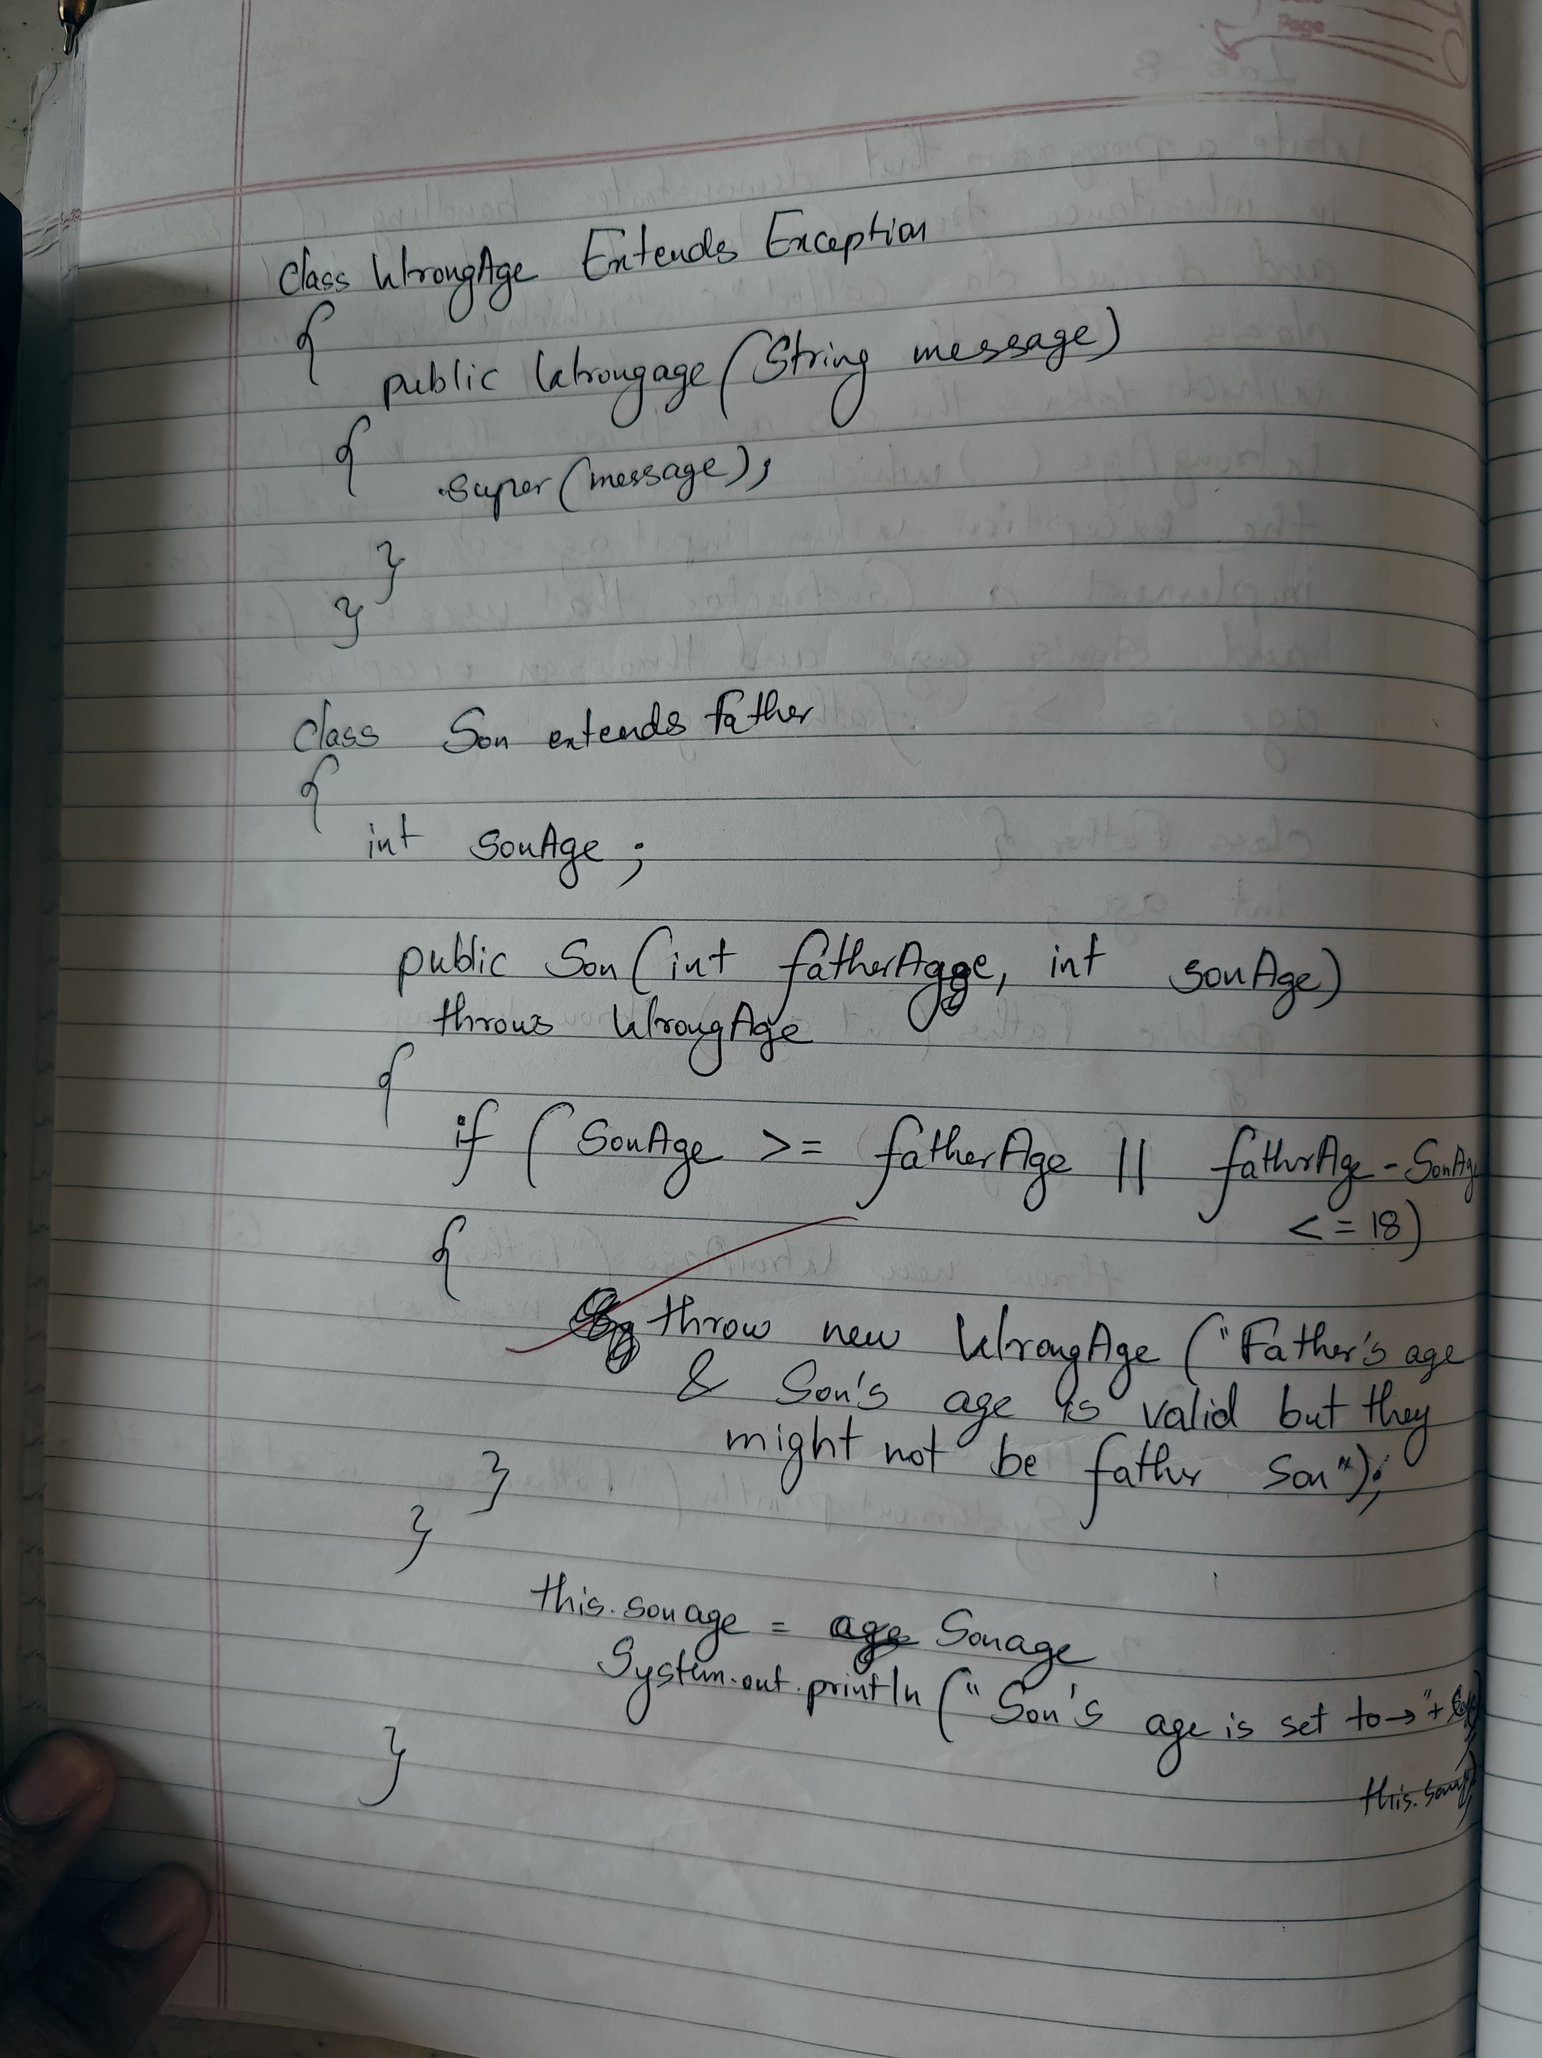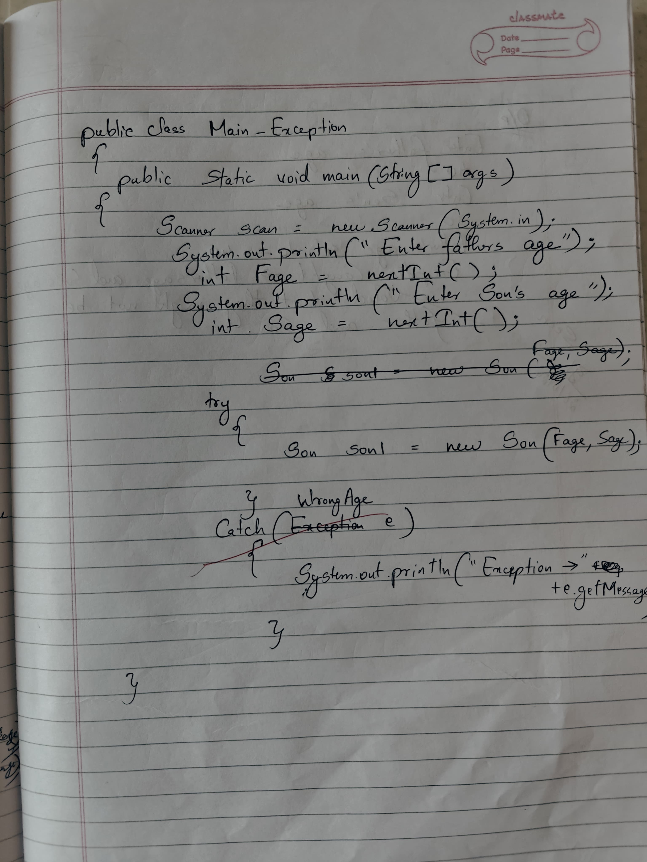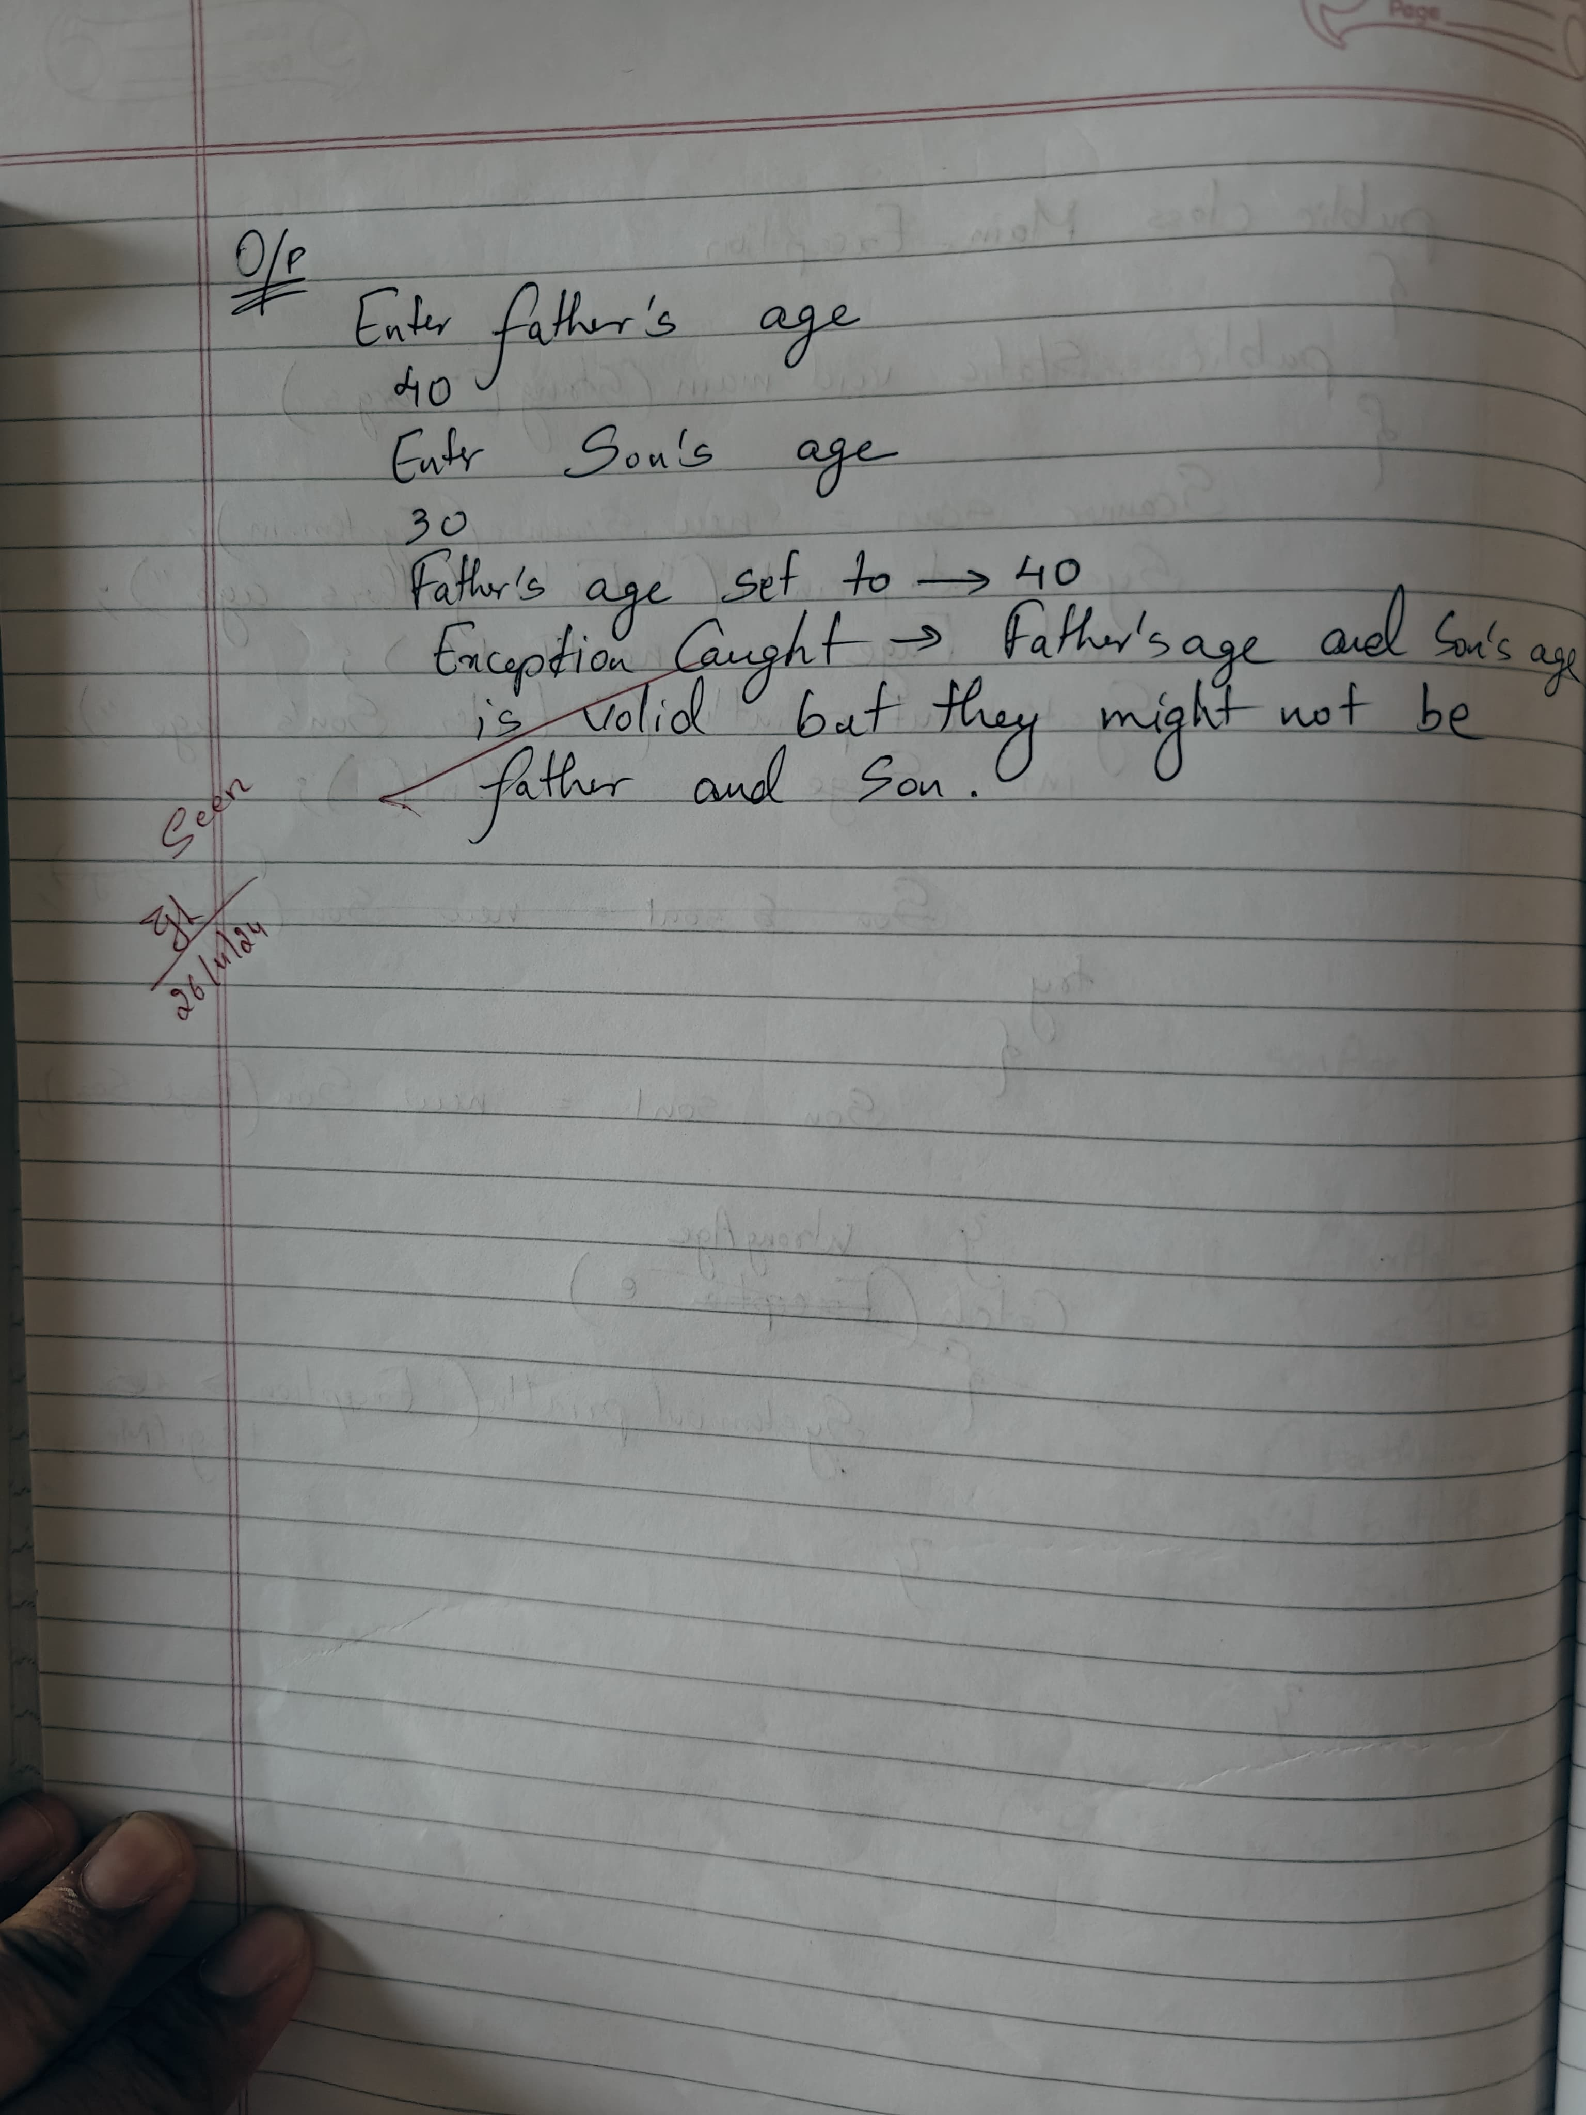

CODE:

import java.util.Scanner;

// Custom exception class

class WrongAge extends ArithmeticException {

    public WrongAge(String msg) {

        super(msg);

    }

}

// Father class to handle father's age and validation

class Father {

    int father_age;

    // Constructor to validate father's age

    public Father(int father_age) throws WrongAge {

        if (father_age <= 0) {

            throw new WrongAge("Father's age can't be negative or zero.");

        } else if (father_age < 18) {

            throw new WrongAge("Father's age is valid, but he can't be a father at such a young age.");

        }

        this.father_age = father_age;

        System.out.println("Father's age is set: " + father_age);

    }

}

// Son class that inherits from Father class and checks son's age

class Son extends Father {

    int son_age;

    // Constructor to validate son's age and age gap with father

    public Son(int son_age, int father_age) throws WrongAge {

        super(father_age);

        if (son_age <= 0) {

            throw new WrongAge("Son's age can't be negative or zero.");

        } else if (father_age - son_age < 18) {

            throw new WrongAge("The age gap between father and son should be greater than 18 years.");

        }

        this.son_age = son_age;

        System.out.println("Son's age is set: " + son_age);

    }

}

public class Main_Exception {

    public static void main(String[] args) {

        Scanner scan = new Scanner(System.in);

        // Input for father's age

        System.out.println("Enter the age of father:");

        int fage = scan.nextInt();

        // Input for son's age

        System.out.println("Enter the age of son:");

        int sage = scan.nextInt();

        try {

            // Create Son object which invokes Father constructor

            Son son = new Son(sage, fage);

        } catch (WrongAge e) {

            // Catch the exception and print the message

            System.out.println("Exception caught -> " + e.getMessage());

        }

        System.out.println("Name: Danish\nUSN:1BM23CS086");

    }

}

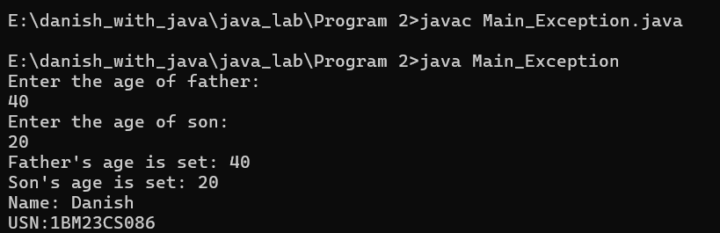

**PROGRAM 9**

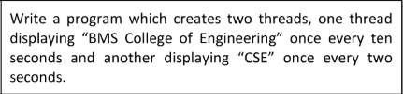

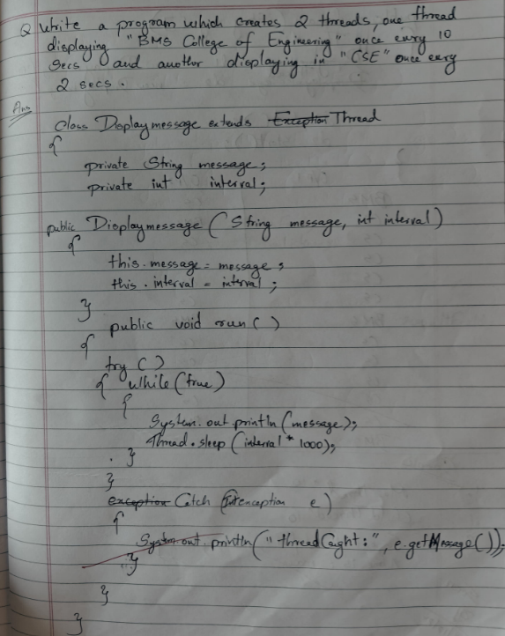

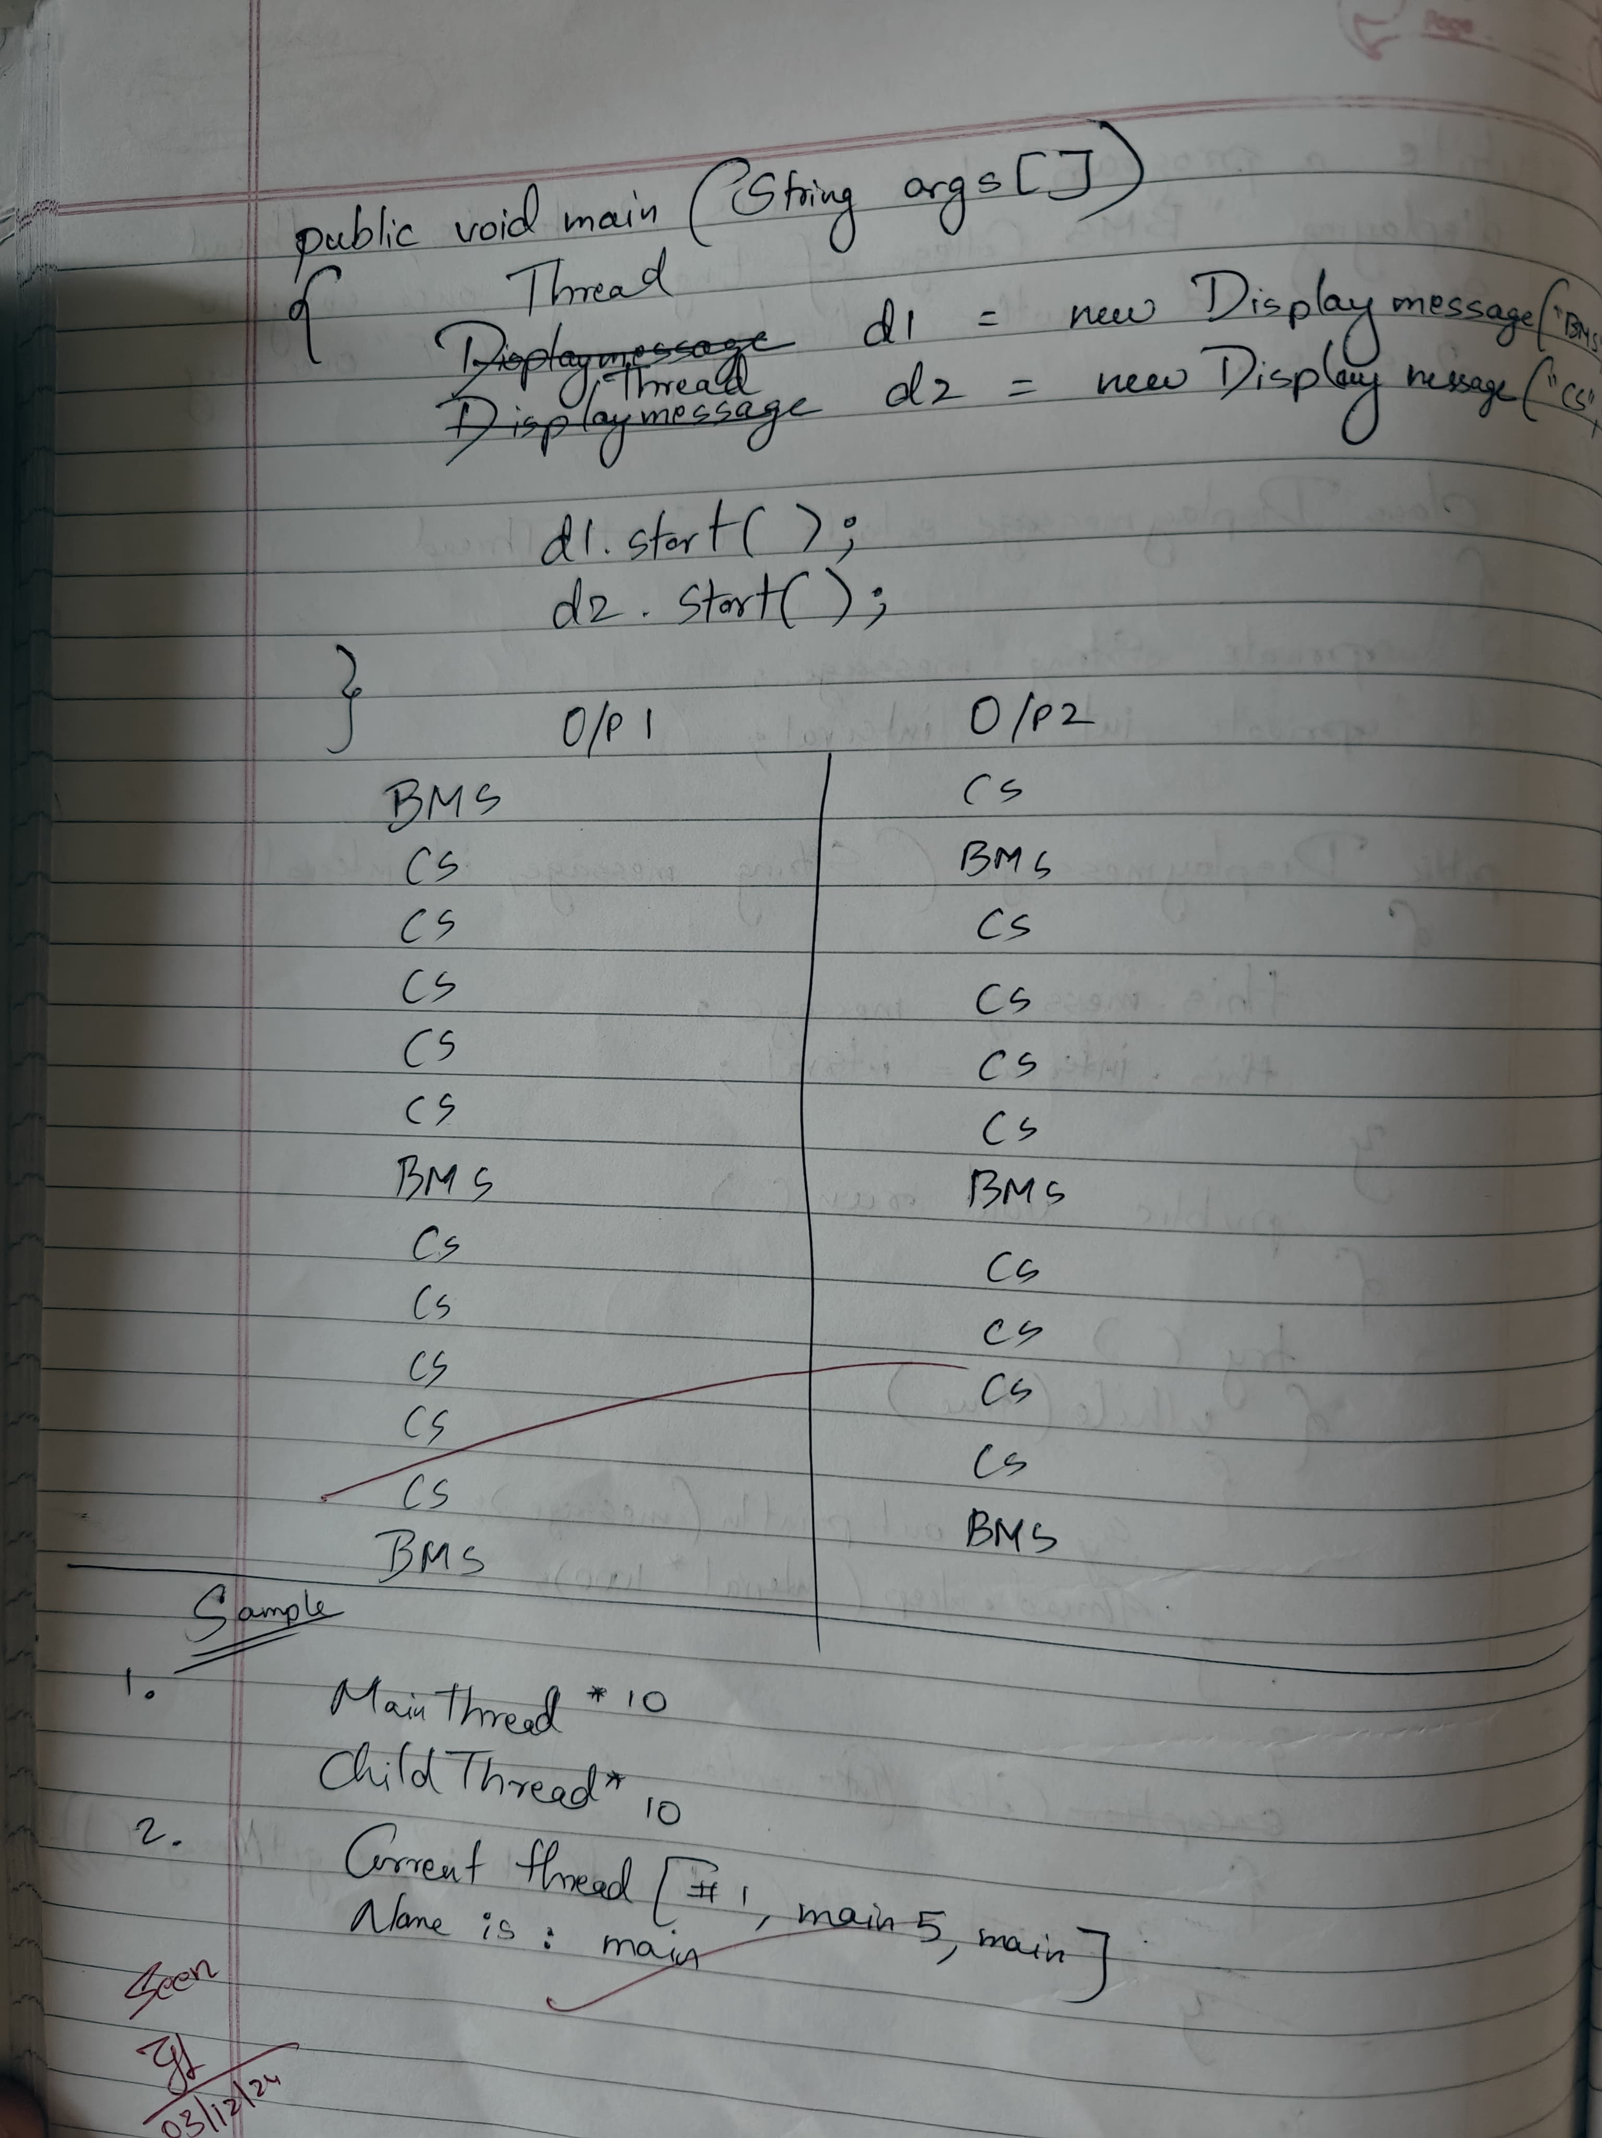

CODE:

class DisplayMessage extends Thread {

    private String message;

    private int interval;

    public DisplayMessage(String message, int interval) {

        this.message = message;

        this.interval = interval;

    }

    public void run() {

        try {

            while (true) {

                System.out.println(message);

                Thread.sleep(interval * 1000); // Convert seconds to milliseconds

            }

        } catch (InterruptedException e) {

            System.out.println("Thread interrupted: " + e.getMessage());

        }

    }

}

public class MultithreadingDemo {

    public static void main(String[] args) {

        Thread thread1 = new DisplayMessage("BMS College of Engineering", 10);

        Thread thread2 = new DisplayMessage("CSE", 2);

        System.out.println("NAME:Danish \nUSN:1BM23CS086");

        thread1.start();

        thread2.start();

    }

}

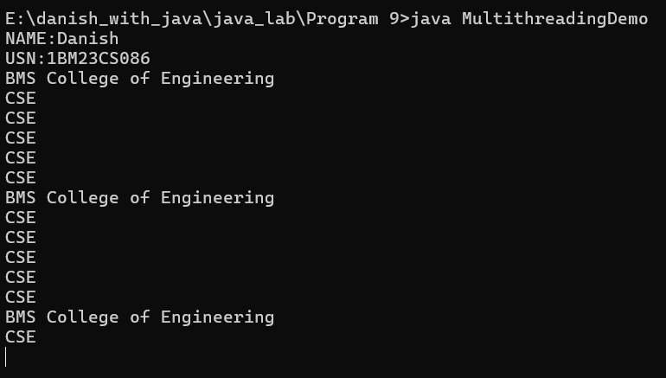

**PROGRAM 10**

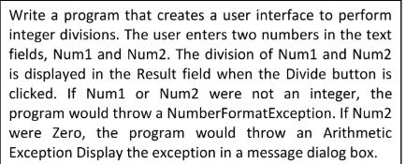

CODE:

import javax.swing.*;

import java.awt.*;

import java.awt.event.ActionEvent;

import java.awt.event.ActionListener;

public class DivisionApp extends JFrame {

    private JTextField num1Field, num2Field, resultField;

    private JButton divideButton;

    public DivisionApp() {

        // Setting up the frame

        setTitle("Integer Division");

        setSize(300, 200);

        setDefaultCloseOperation(JFrame.EXIT_ON_CLOSE);

        setLayout(new GridLayout(4, 2));

        // Creating components

        JLabel num1Label = new JLabel("Num1:");

        num1Field = new JTextField();

        JLabel num2Label = new JLabel("Num2:");

        num2Field = new JTextField();

        JLabel resultLabel = new JLabel("Result:");

        resultField = new JTextField();

        resultField.setEditable(false);

        divideButton = new JButton("Divide");

        // Adding components to the frame

        add(num1Label);

        add(num1Field);

        add(num2Label);

        add(num2Field);

        add(resultLabel);

        add(resultField);

        add(new JLabel()); // Empty cell

        add(divideButton);

        // Adding action listener to the button

        divideButton.addActionListener(new ActionListener() {

            @Override

            public void actionPerformed(ActionEvent e) {

                try {

                    int num1 = Integer.parseInt(num1Field.getText());

                    int num2 = Integer.parseInt(num2Field.getText());

                    if (num2 == 0) {

                        throw new ArithmeticException("Division by zero");

                    }

                    int result = num1 / num2;

                    resultField.setText(String.valueOf(result));

                } catch (NumberFormatException ex) {

                    JOptionPane.showMessageDialog(DivisionApp.this,

                            "Please enter valid integers.", "Number Format Error",

                            JOptionPane.ERROR_MESSAGE);

                } catch (ArithmeticException ex) {

                    JOptionPane.showMessageDialog(DivisionApp.this,

                            ex.getMessage(), "Arithmetic Error",

                            JOptionPane.ERROR_MESSAGE);

                }

            }

        });

    }

    public static void main(String[] args) {

        SwingUtilities.invokeLater(() -> {

            DivisionApp app = new DivisionApp();

            app.setVisible(true);

        });

    }

}

